**Lab13 – Understanding Azure Files Storage - Azure**

Azure Storage provides three types of storage accounts. Each type supports different features and has its own pricing model. Consider these differences before you create a storage account to determine the type of account that is best for your applications. The types of storage accounts are:

* [**General-purpose v2 accounts**](https://docs.microsoft.com/en-us/azure/storage/common/storage-account-overview#general-purpose-v2-accounts) (recommended for most scenarios)
* [**General-purpose v1 accounts**](https://docs.microsoft.com/en-us/azure/storage/common/storage-account-overview#general-purpose-v1-accounts)
* [**Blob storage accounts**](https://docs.microsoft.com/en-us/azure/storage/common/storage-account-overview#blob-storage-accounts)

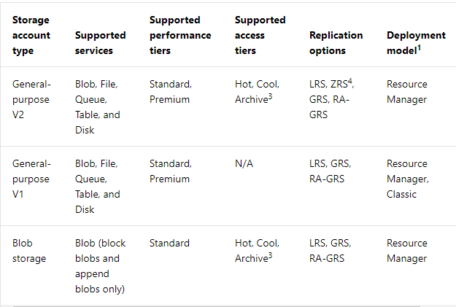

1Using the Azure Resource Manager deployment model is recommended. Storage accounts using the classic deployment model can still be created in some locations, and existing classic accounts continue to be supported. For more information, see [Azure Resource Manager vs. classic deployment: Understand deployment models and the state of your resources](https://docs.microsoft.com/en-us/azure/azure-resource-manager/resource-manager-deployment-model).

2All storage accounts are encrypted using Storage Service Encryption (SSE) for data at rest. For more information, see [Azure Storage Service Encryption for Data at Rest](https://docs.microsoft.com/en-us/azure/storage/common/storage-service-encryption).

3The Archive tier is available at level of an individual blob only, not at the storage account level. Only block blobs and append blobs can be archived. For more information, see [Azure Blob storage: Hot, Cool, and Archive storage tiers](https://docs.microsoft.com/en-us/azure/storage/blobs/storage-blob-storage-tiers).

4Zone-redundant storage (ZRS) is available only for standard general-purpose v2 storage accounts. For more information about ZRS, see [Zone-redundant storage (ZRS): Highly available Azure Storage applications](https://docs.microsoft.com/en-us/azure/storage/common/storage-redundancy-zrs). For more information about other replication options, see [Azure Storage replication](https://docs.microsoft.com/en-us/azure/storage/common/storage-redundancy).

**General-purpose v2 accounts**

General-purpose v2 storage accounts support the latest Azure Storage features and incorporate all of the functionality of general-purpose v1 and Blob storage accounts. General-purpose v2 accounts deliver the lowest per-gigabyte capacity prices for Azure Storage, as well as industry-competitive transaction prices. General-purpose v2 storage accounts support these Azure Storage services:

* Blobs (all types: Block, Append, Page)
* Files
* Disks
* Queues
* Tables

**Note**

Microsoft recommends using a general-purpose v2 storage account for most scenarios. You can easily upgrade a general-purpose v1 or Blob storage account to a general-purpose v2 account with no downtime and without the need to copy data.

For more information on upgrading to a general-purpose v2 account, see [**Upgrade to a general-purpose v2 storage account**](https://docs.microsoft.com/en-us/azure/storage/common/storage-account-upgrade).

General-purpose v2 storage accounts offer multiple access tiers for storing data based on your usage patterns. For more information, see [Access tiers for block blob data](https://docs.microsoft.com/en-us/azure/storage/common/storage-account-overview#access-tiers-for-block-blob-data).

**General-purpose v1 accounts**

General-purpose v1 accounts provide access to all Azure Storage services, but may not have the latest features or the lowest per gigabyte pricing. General-purpose v1 storage accounts support these Azure Storage services:

* Blobs (all types)
* Files
* Disks
* Queues
* Tables

While general-purpose v2 accounts are recommended in most cases, general-purpose v1 accounts are best suited to these scenarios:

* Your applications require the Azure classic deployment model. General-purpose v2 accounts and Blob storage accounts support only the Azure Resource Manager deployment model.
* Your applications are transaction-intensive or use significant geo-replication bandwidth, but do not require large capacity. In this case, general-purpose v1 may be the most economical choice.
* You use a version of the [Storage Services REST API](https://msdn.microsoft.com/library/azure/dd894041.aspx) that is earlier than 2014-02-14 or a client library with a version lower than 4.x, and cannot upgrade your application.

**Azure Files**

Azure Files offers fully managed file shares in the cloud that are accessible via the industry standard [Server Message Block (SMB) protocol](https://msdn.microsoft.com/library/windows/desktop/aa365233.aspx). Azure file shares can be mounted concurrently by cloud or on-premises deployments of Windows, Linux, and macOS. Additionally, Azure file shares can be cached on Windows Servers with Azure File Sync for fast access near where the data is being used.

Azure file shares can be used to:

* **Replace or supplement on-premises file servers**:  
  Azure Files can be used to completely replace or supplement traditional on-premises file servers or NAS devices. Popular operating systems such as Windows, macOS, and Linux can directly mount Azure file shares wherever they are in the world. Azure file shares can also be replicated with Azure File Sync to Windows Servers, either on-premises or in the cloud, for performance and distributed caching of the data where it's being used.
* **"Lift and shift" applications**:  
  Azure Files makes it easy to "lift and shift" applications to the cloud that expect a file share to store file application or user data. Azure Files enables both the "classic" lift and shift scenario, where both the application and its data are moved to Azure, and the "hybrid" lift and shift scenario, where the application data is moved to Azure Files, and the application continues to run on-premises.
* **Simplify cloud development**:  
  Azure Files can also be used in numerous ways to simplify new cloud development projects. For example:
  + **Shared application settings**:  
    A common pattern for distributed applications is to have configuration files in a centralized location where they can be accessed from many application instances. Application instances can load their configuration through the File REST API, and humans can access them as needed by mounting the SMB share locally.
  + **Diagnostic share**:  
    An Azure file share is a convenient place for cloud applications to write their logs, metrics, and crash dumps. Logs can be written by the application instances via the File REST API, and developers can access them by mounting the file share on their local machine. This enables great flexibility, as developers can embrace cloud development without having to abandon any existing tooling they know and love.
  + **Dev/Test/Debug**:  
    When developers or administrators are working on VMs in the cloud, they often need a set of tools or utilities. Copying such utilities and tools to each VM can be a time consuming exercise. By mounting an Azure file share locally on the VMs, a developer and administrator can quickly access their tools and utilities, no copying required.

## Key benefits

* **Shared access**. Azure file shares support the industry standard SMB protocol, meaning you can seamlessly replace your on-premises file shares with Azure file shares without worrying about application compatibility. Being able to share a file system across multiple machines, applications/instances is a significant advantage with Azure Files for applications that need shareability.
* **Fully managed**. Azure file shares can be created without the need to manage hardware or an OS. This means you don't have to deal with patching the server OS with critical security upgrades or replacing faulty hard disks.
* **Scripting and tooling**. PowerShell cmdlets and Azure CLI can be used to create, mount, and manage Azure file shares as part of the administration of Azure applications.You can create and manage Azure file shares using Azure portal and Azure Storage Explorer.
* **Resiliency**. Azure Files has been built from the ground up to be always available. Replacing on-premises file shares with Azure Files means you no longer have to wake up to deal with local power outages or network issues.
* **Familiar programmability**. Applications running in Azure can access data in the share via file [system I/O APIs](https://msdn.microsoft.com/library/system.io.file.aspx). Developers can therefore leverage their existing code and skills to migrate existing applications. In addition to System IO APIs, you can use [Azure Storage Client Libraries](https://msdn.microsoft.com/library/azure/dn261237.aspx) or the [Azure Storage REST API](https://docs.microsoft.com/en-us/rest/api/storageservices/file-service-rest-api).

**Topology**

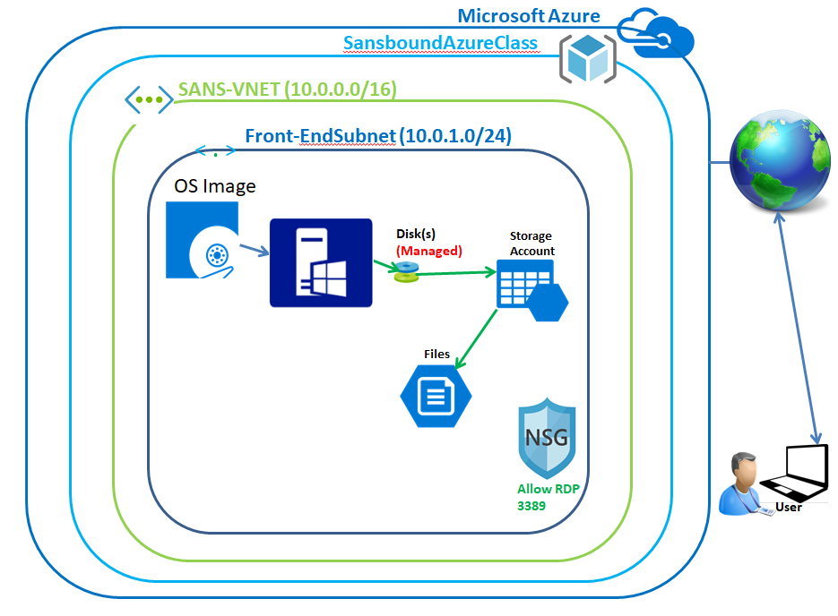

**Back-End Topology:**

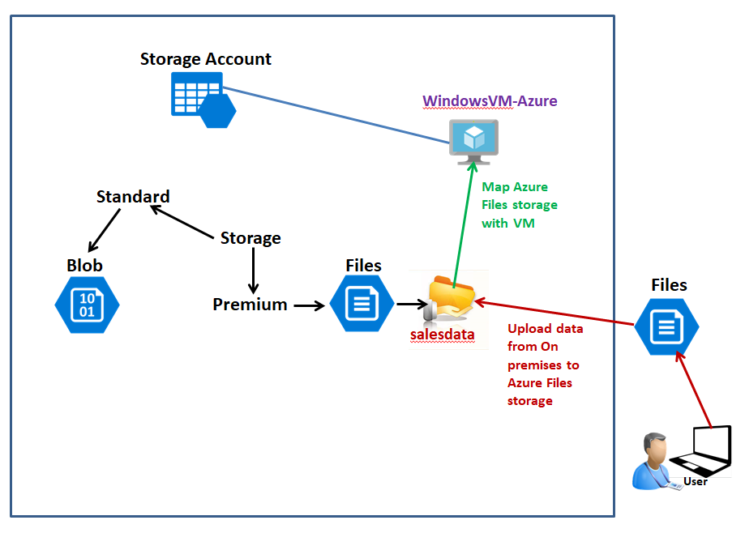

In Azure portal, click “Resource groups”.

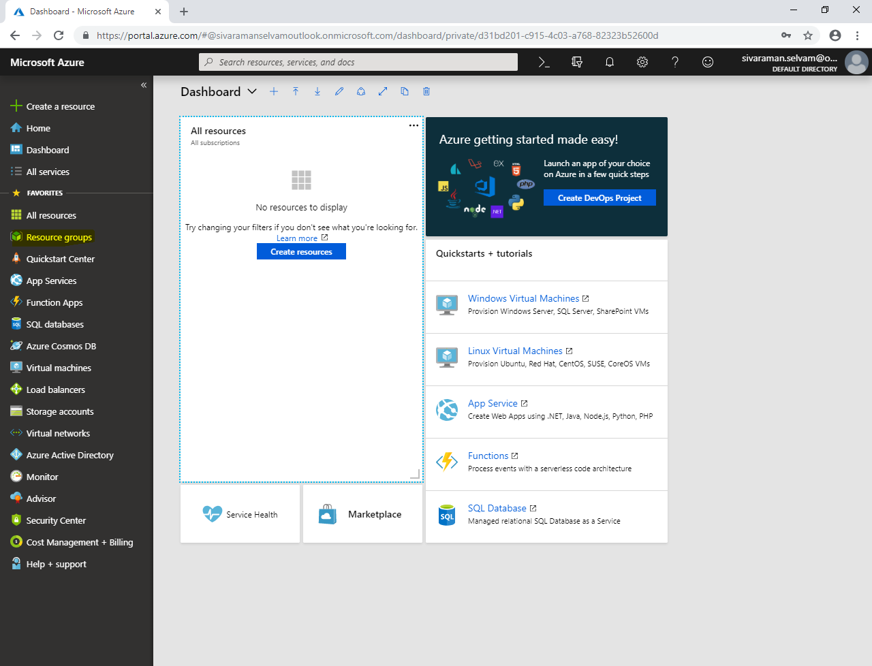

In **“Resource groups”** click **“Add”**.

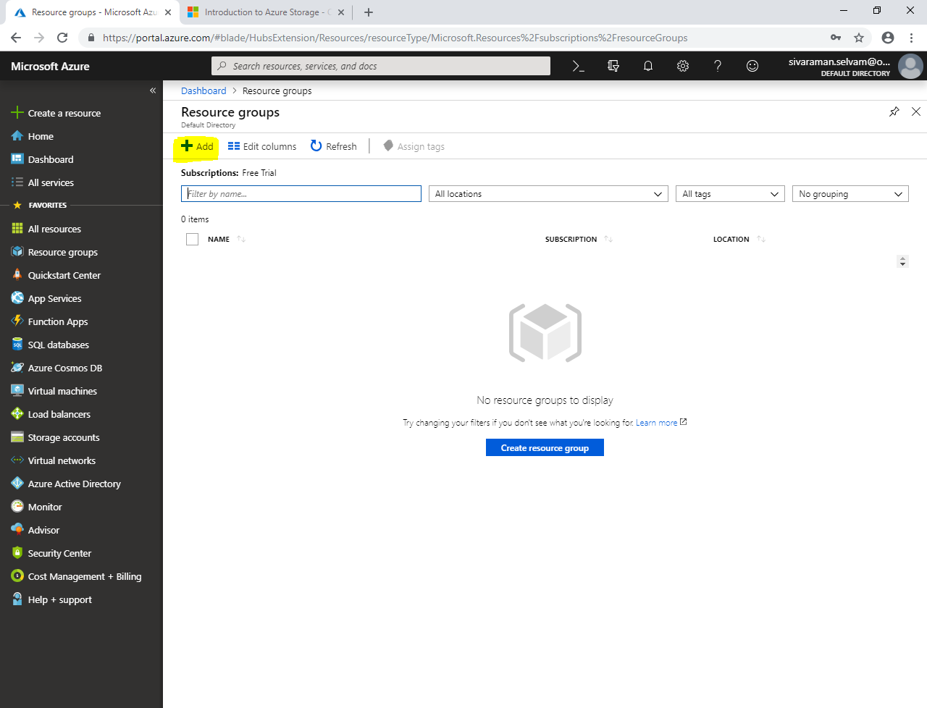

While create **“Resource group”**

Type **“Resource group name”** as **“SansboundAzureClass”**.

In **“Subscription”** as **“Free Trial”**.

In **“Resource group location”** select **“South India”**.

Click **“Create”**.

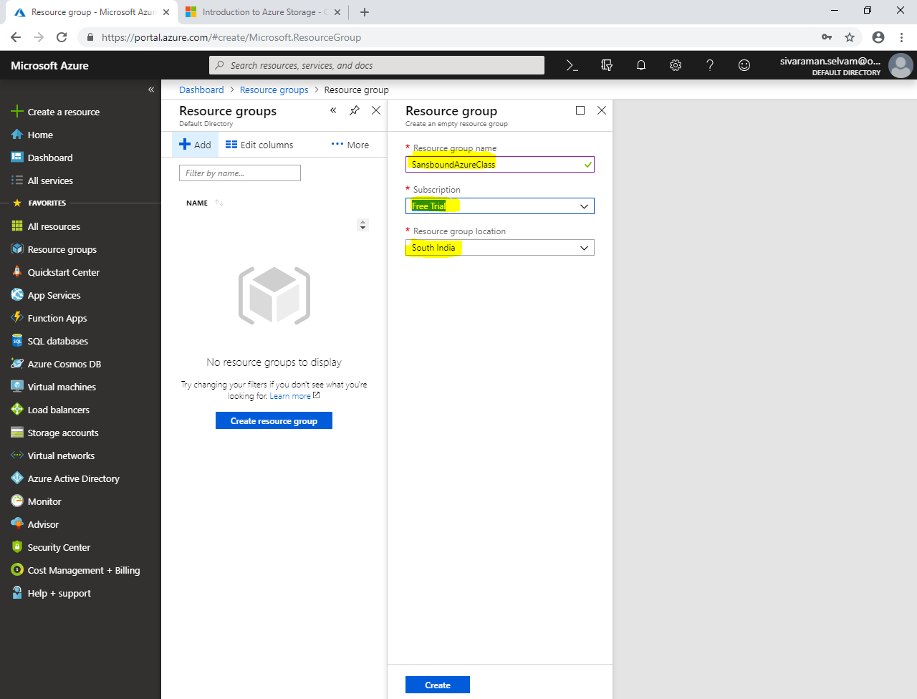

In Dashboard, click **“Virtual networks”**,

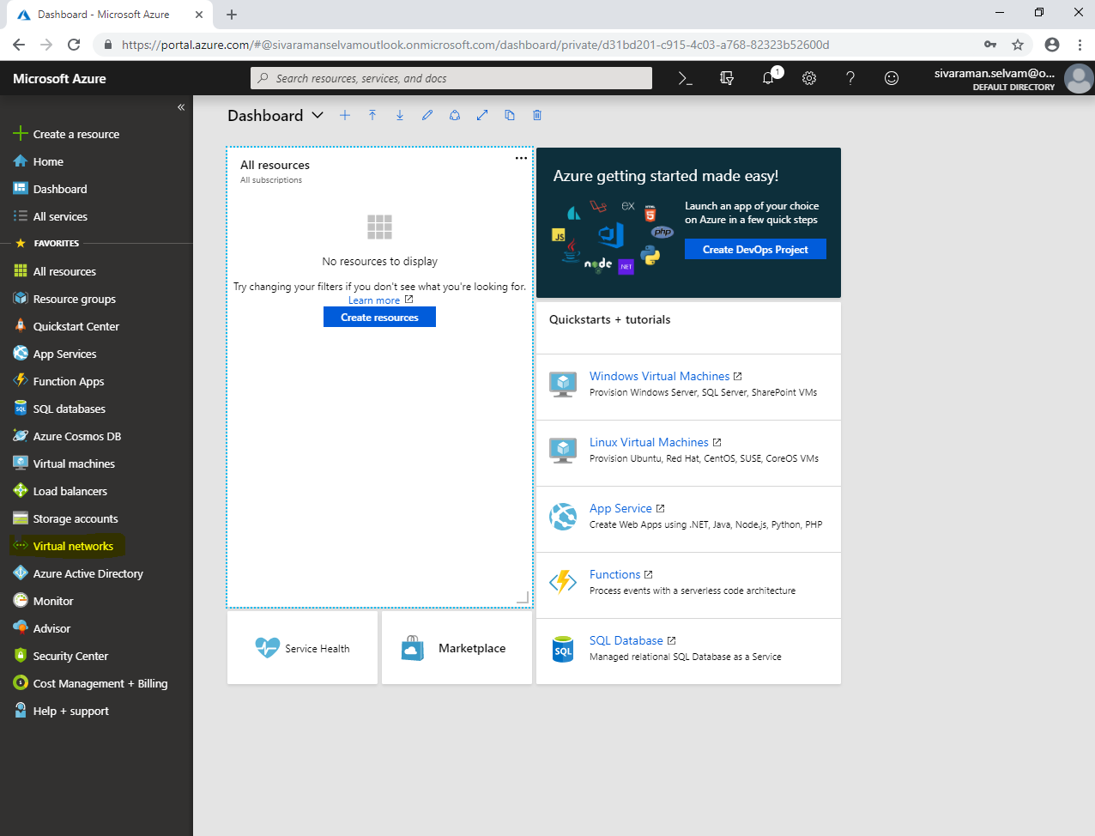

In **“Virtual networks”** click **“Add”**.

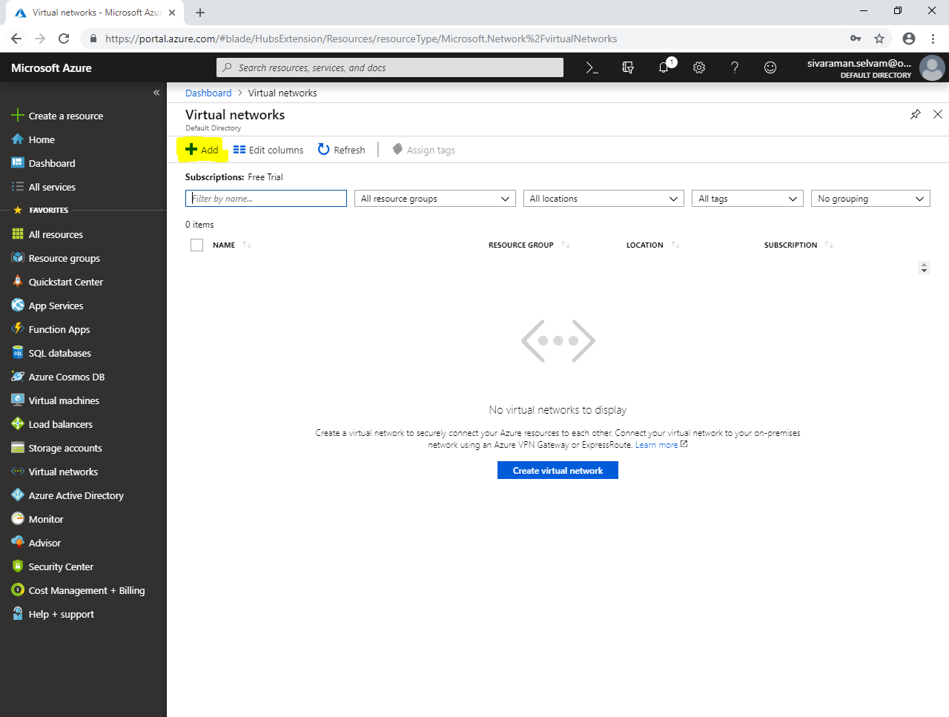

While create virtual network,

Type **“Virtual network name”** as **“SANS-VNET”**.

Type **“Address range”** as **10.0.0.0/16.**

Select **“Subscription”** as **“Free Trial”**.

Select **“Resource group”** as **“SansboundAzureClass”**.

Select **“Location”** as **“South India”**.

In Subnet type **“Subnet name”** as **“Front-EndSubnet”**.

Type **“Front-EndSubnet”** address as **10.0.1.0/24**.

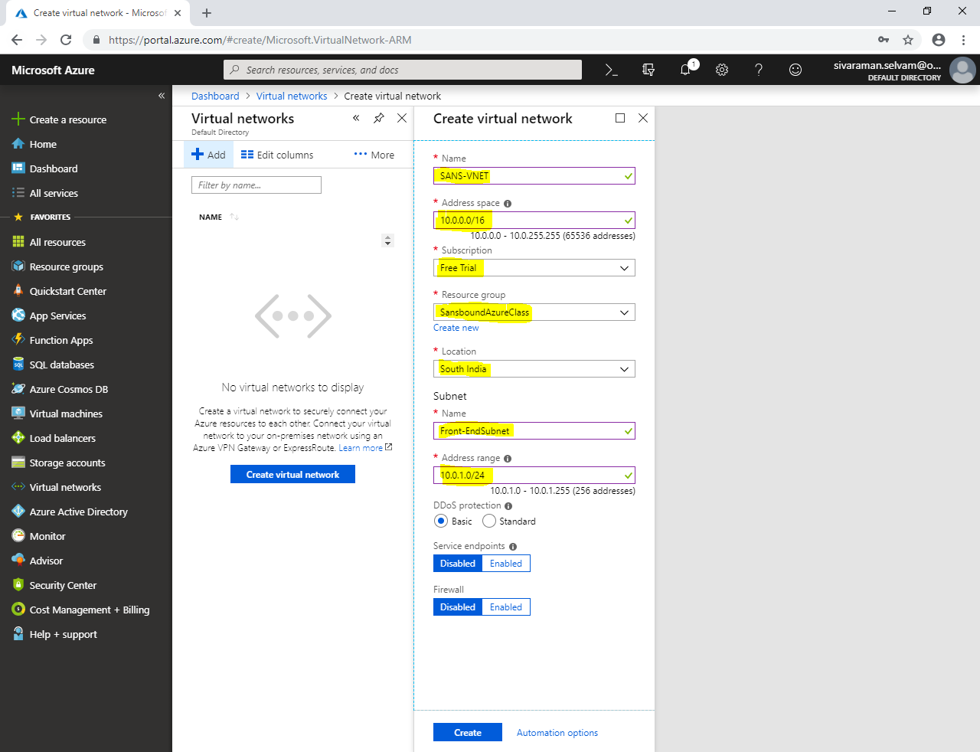

Click **“Create”.**

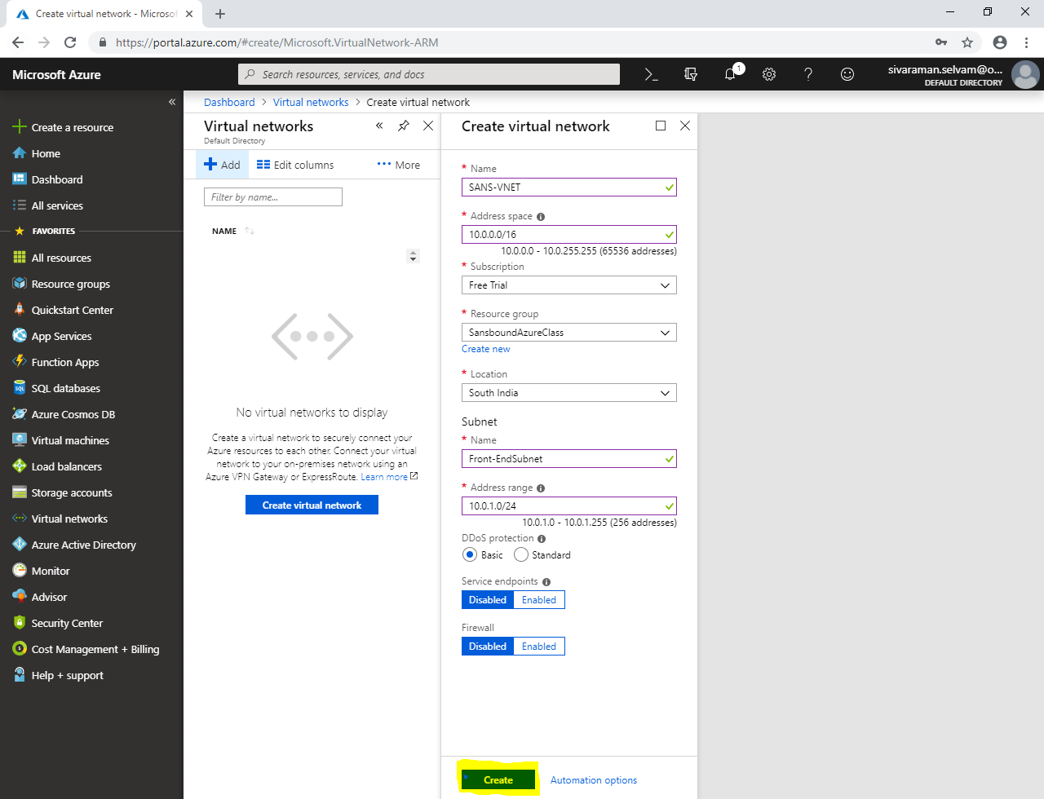

Click **“Virtual machines”** in left side panel.

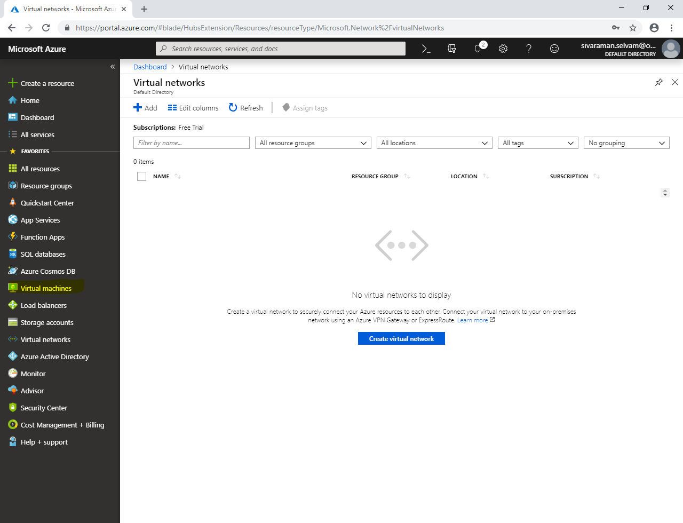

In **“Virtual machines”.**

Click **“Add”**.

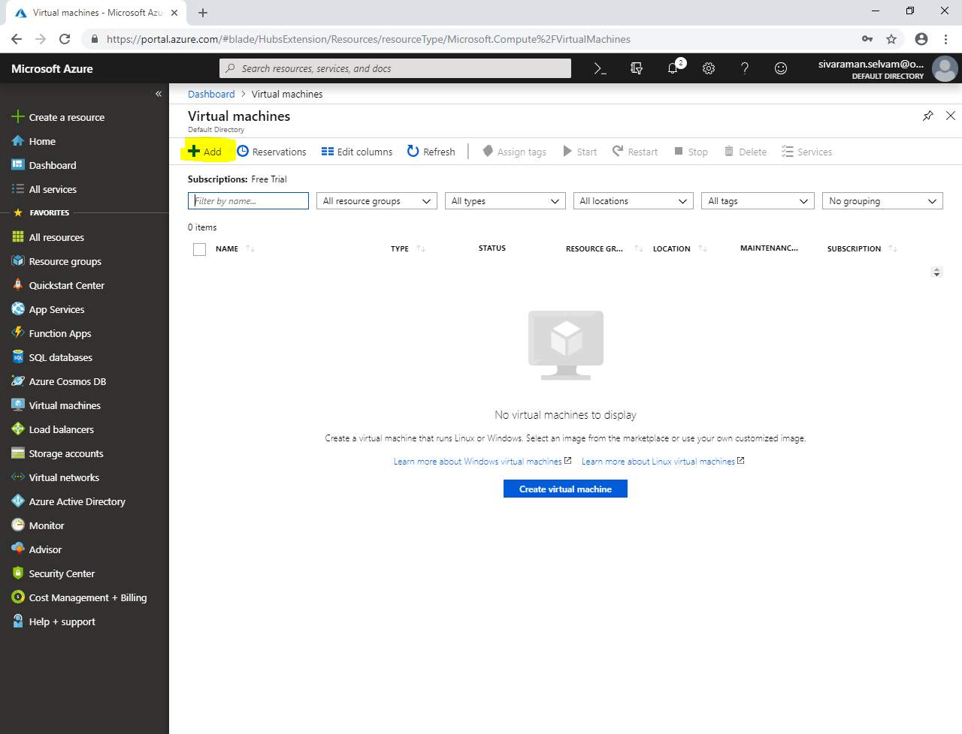

Type **“Virtual machine name”** as **“WindowsVM-Azure”**.

Select **“Region”** as **“South India”**.

Select **“Image”** as **“Windows Server 2008 R2”**.

Change **“VM Size”** as **“Standard B1s”**.

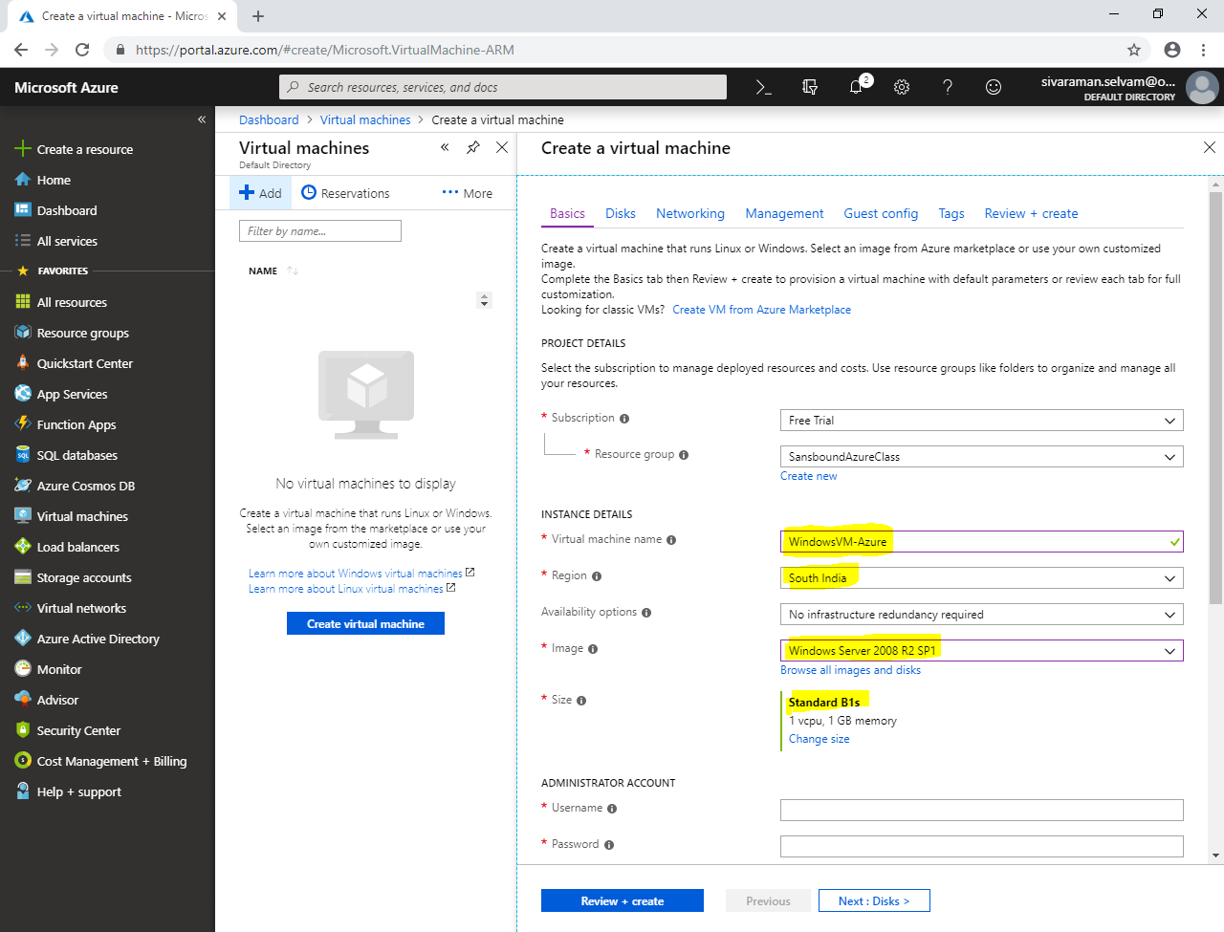

In **“Administrator Account”**

Type **“Username”** as sanbound

Type **“Password”** type password for Windows server.

In **“Inbound Port Rules”**.

Click **“Public inbound ports”** as **“Allow selected ports”**.

**“Select inbound ports”** as **“RDP”**.

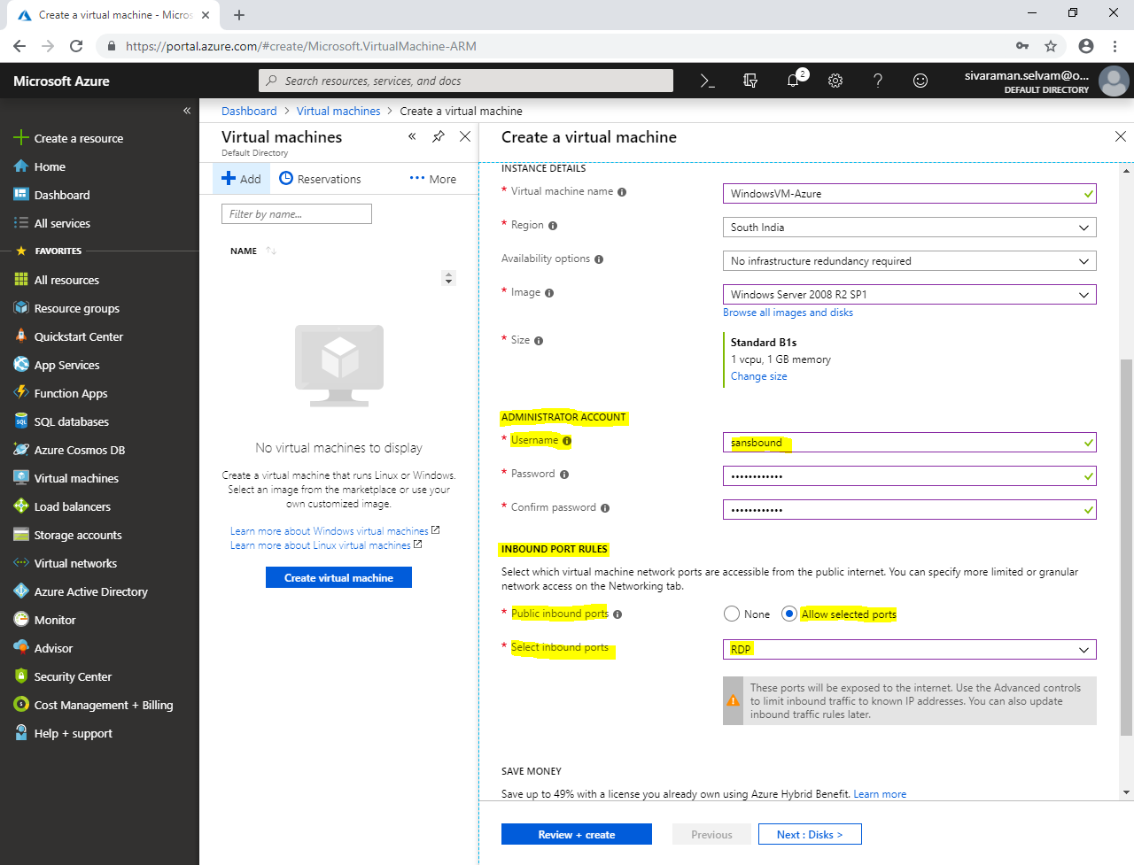

In **“Save Money”**.

Click **“Yes”** for Already have a Windows license.

Need to check **“Confirmation”** box.

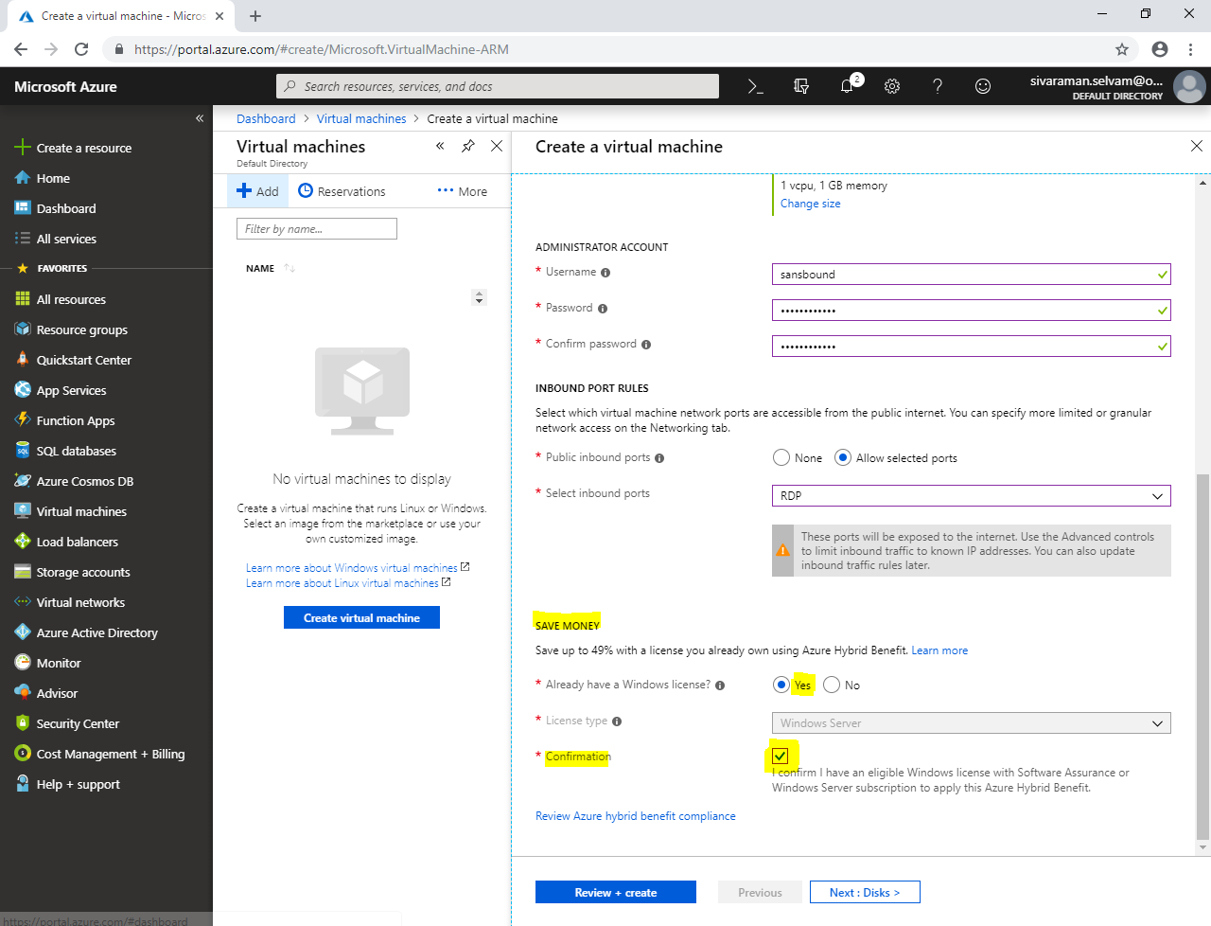

Click **“Next : Disks >”**.

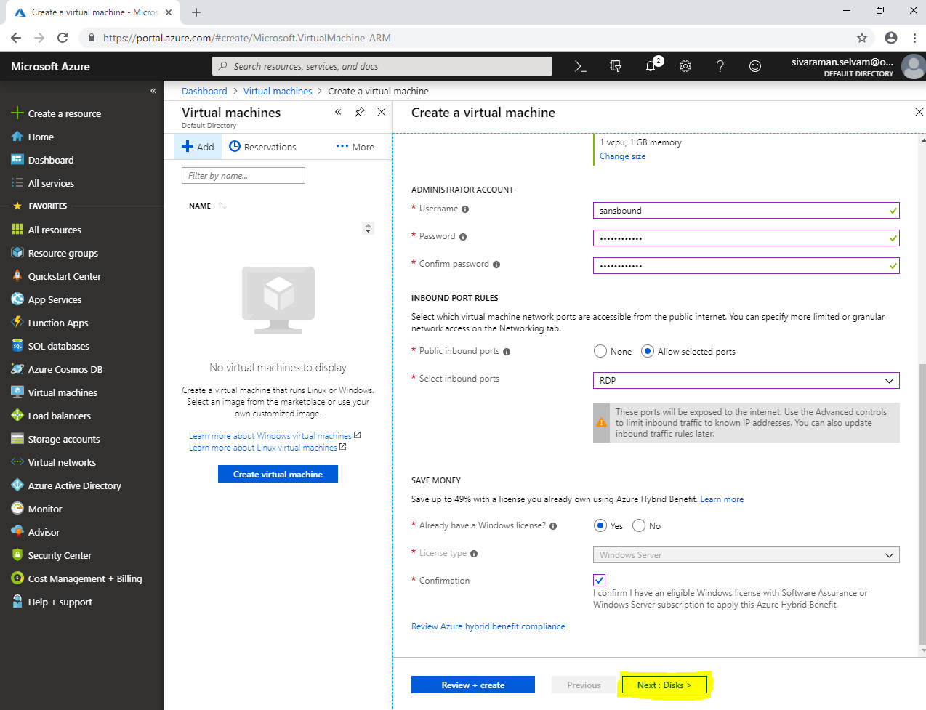

In **“Disks”**.

Click **“Next : Networking”**.

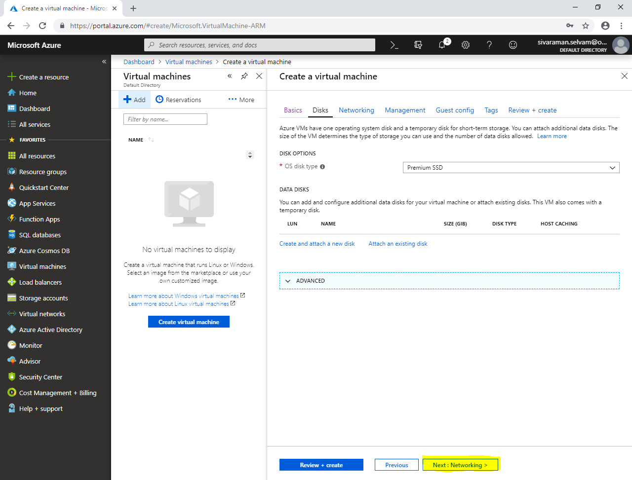

In **“Networking”**

Ensure the VNET and Subnet details.

Click **“Next : Management >”**.

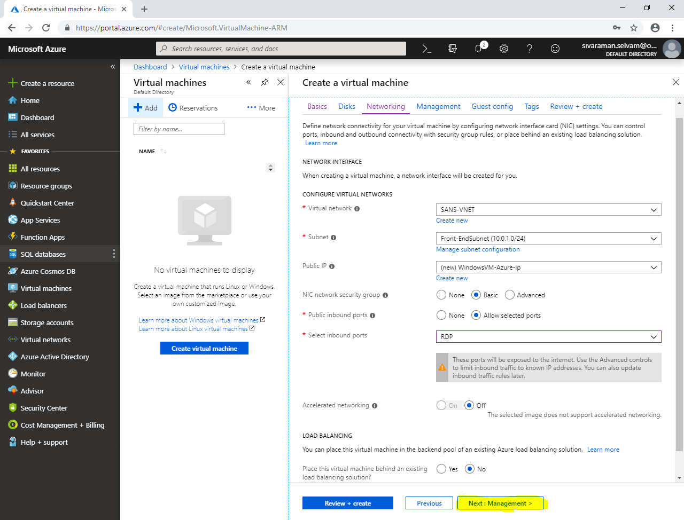

In **“Management”**.

Click **“Next : Guest config >”**.

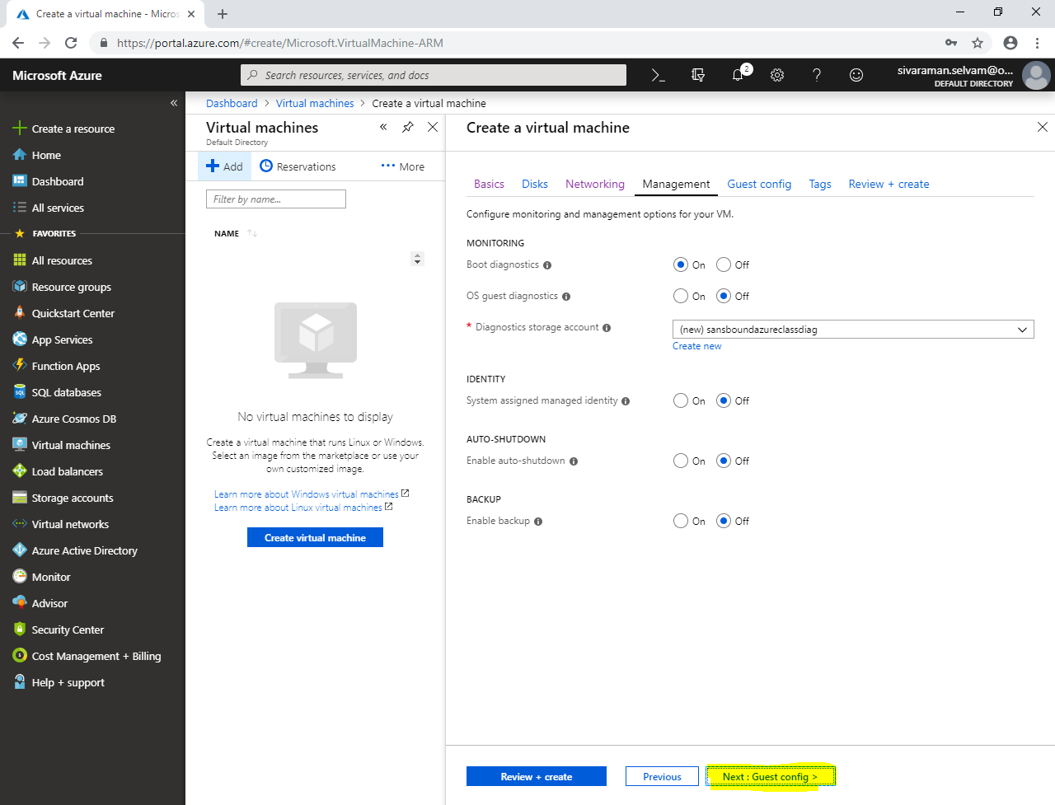

Click **“Next : Tags >”**.

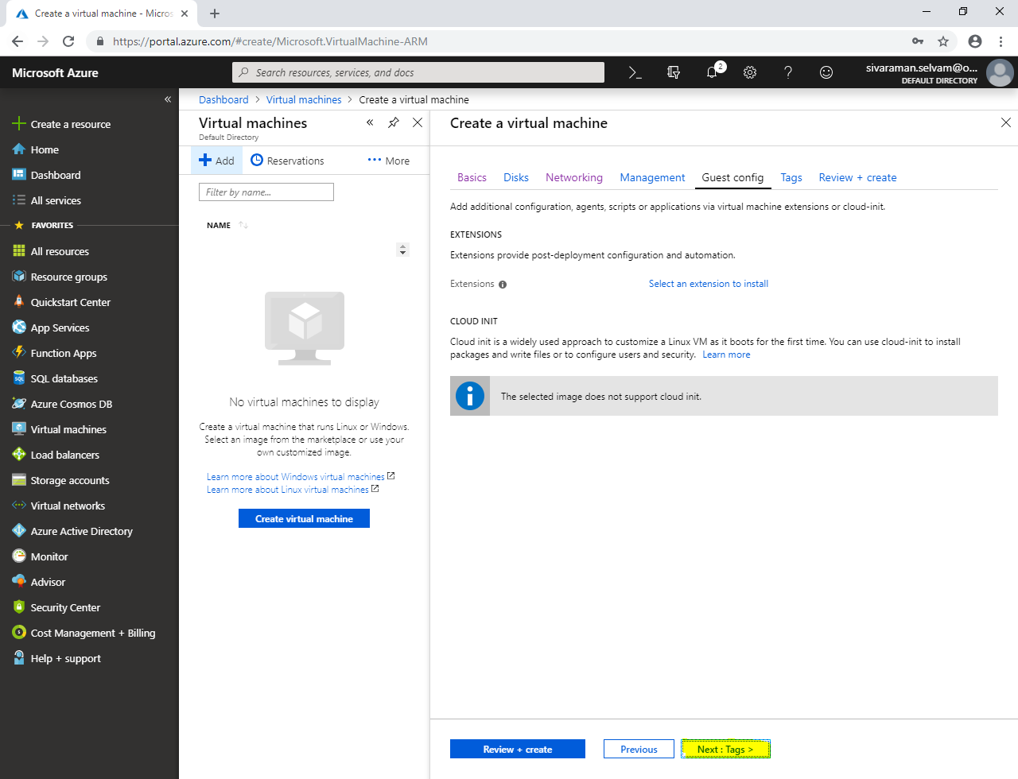

In **“Tags”.**

Click **“Next : Review + create”**.

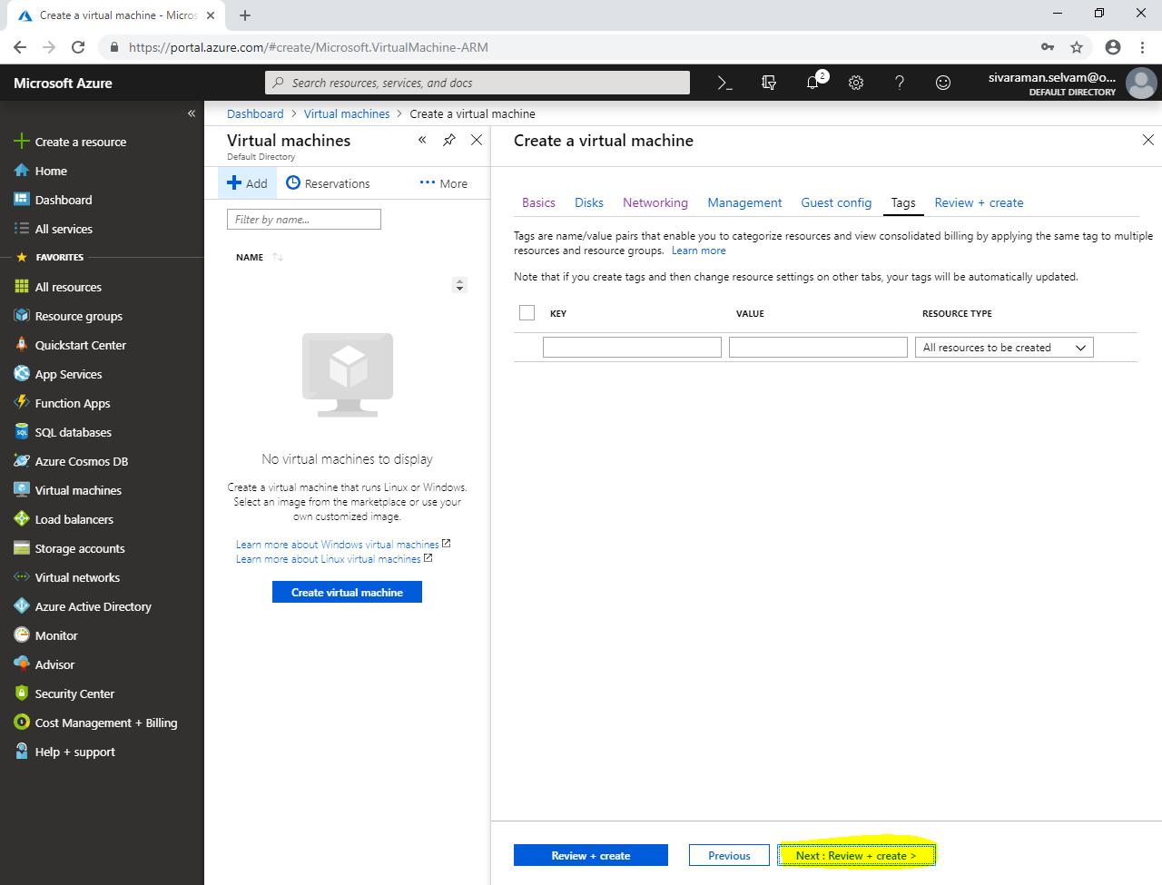

Click **“Create”.**

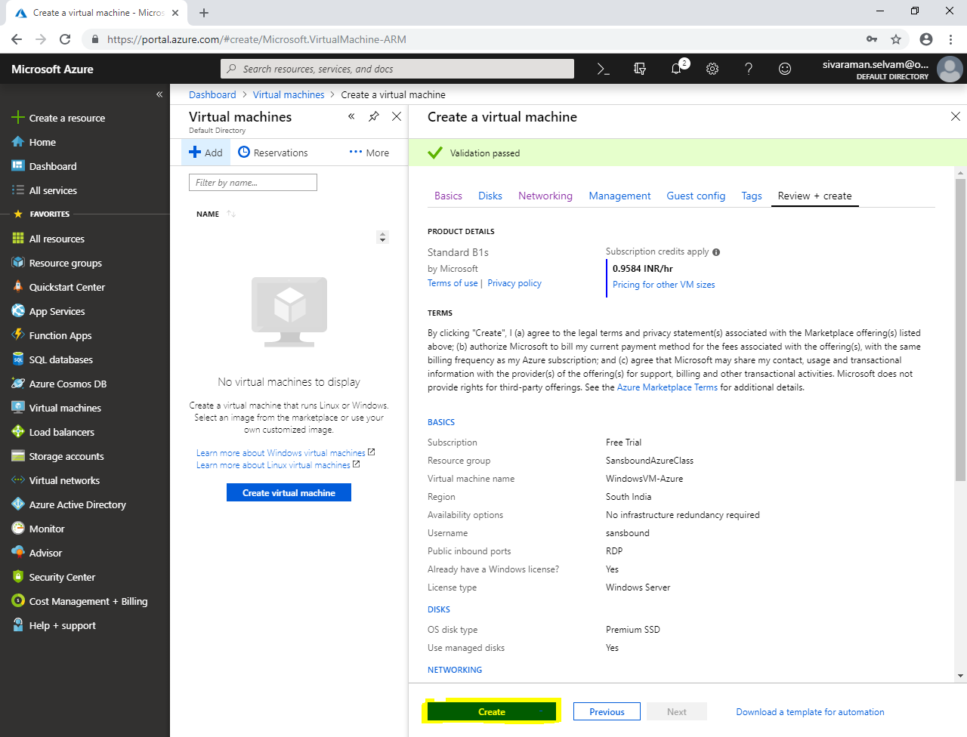

Click **“All resources”**.

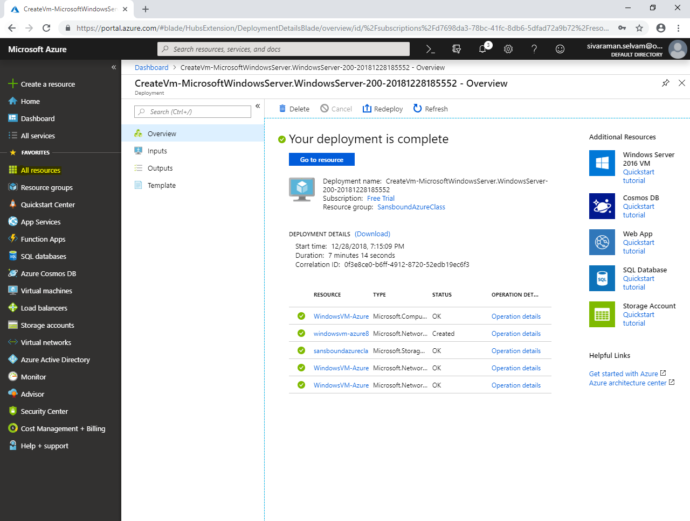

In **“Dasboard”** click **”Storage accounts”**.

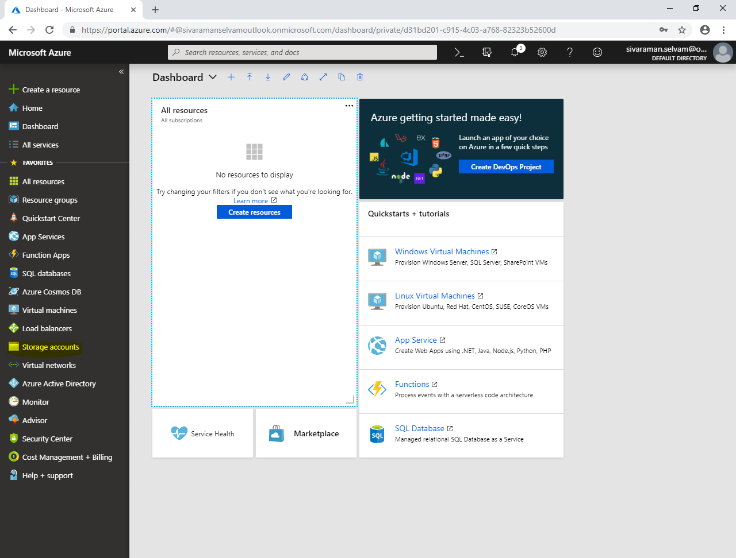

In **“Storage accounts”** click **“sansboundazureclassdiag”**.

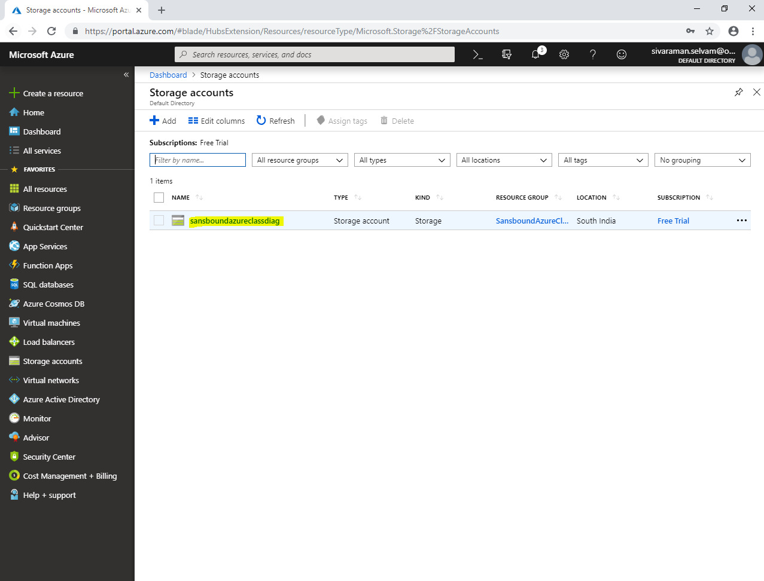

In **“sansboundazureclassdiag”**.

Click **“File”**.

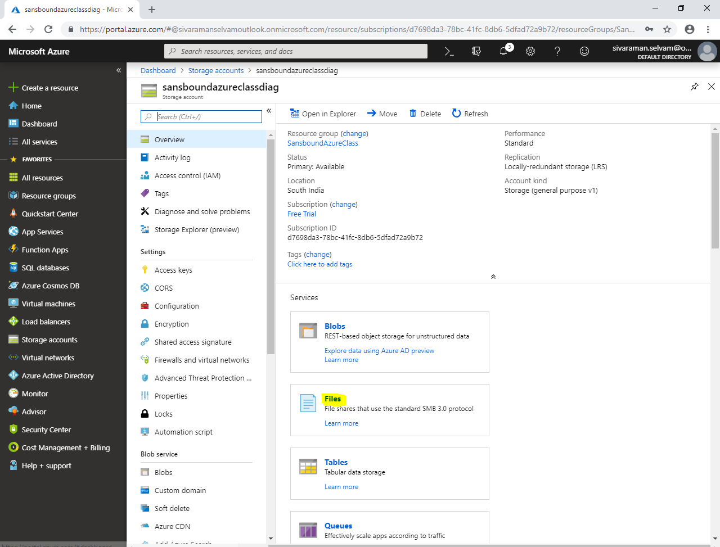

In **“Files”**

Click **“File share”**.

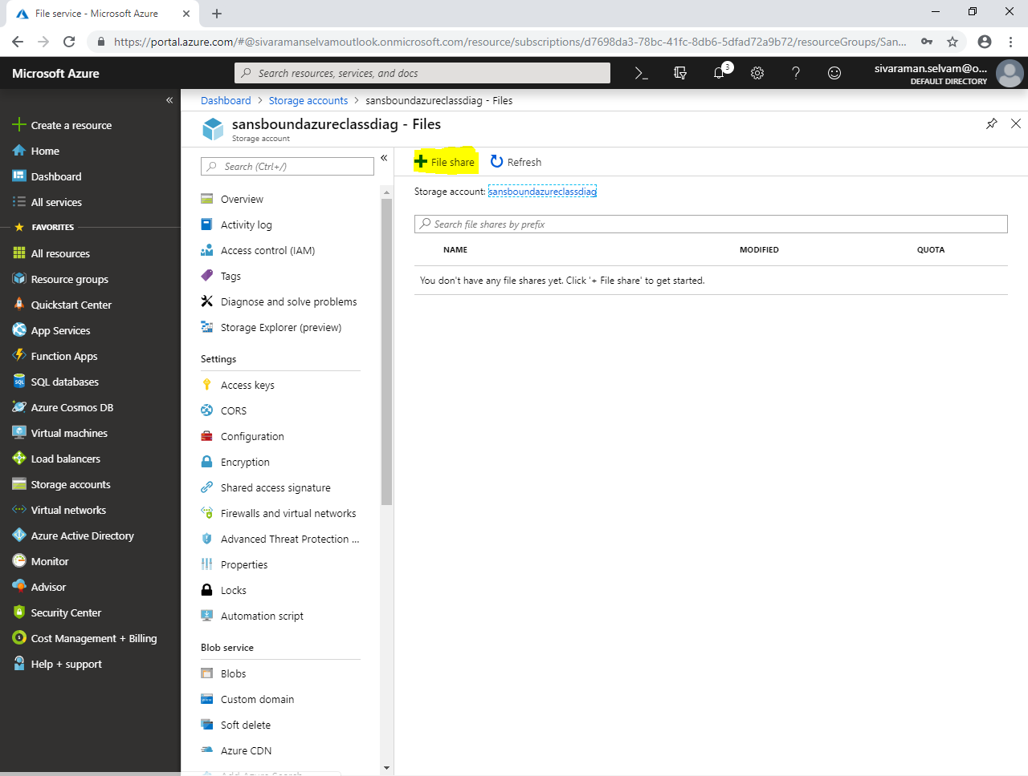

In **“File Share”**

Type **“File share”** name as **“salesdata”**.

Type **“Quota”** as **5 GiB**

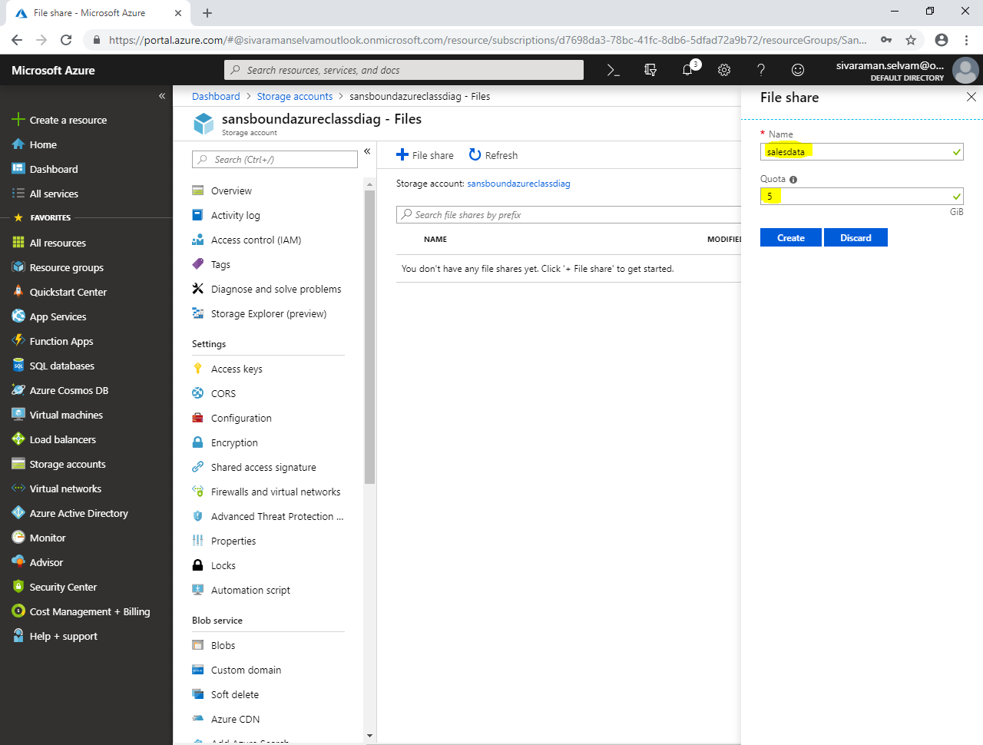

Click **“Create”.**

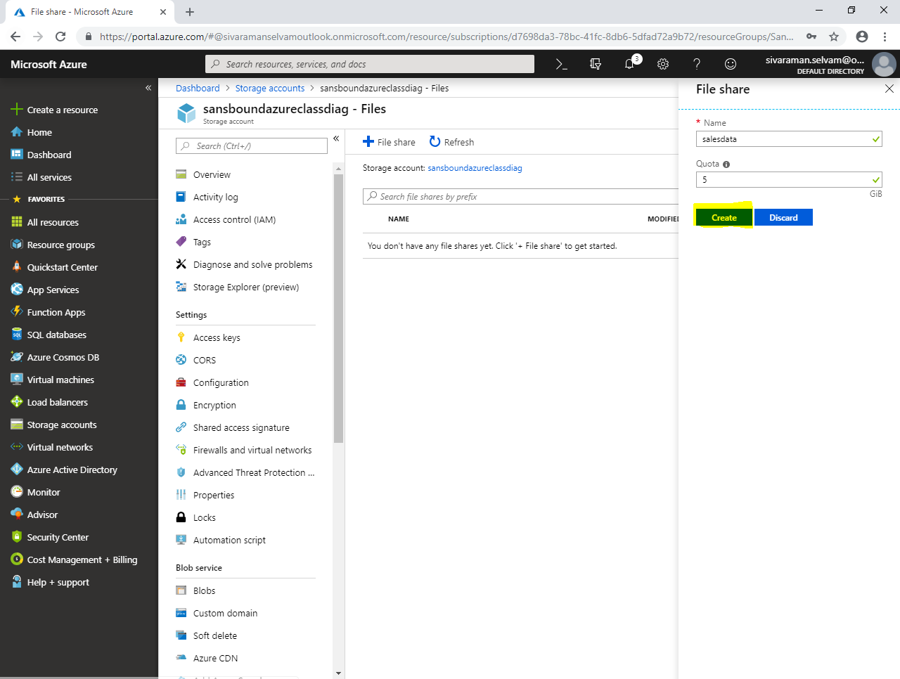

You have successfully added the File Share.

Click **“salesdata”**.

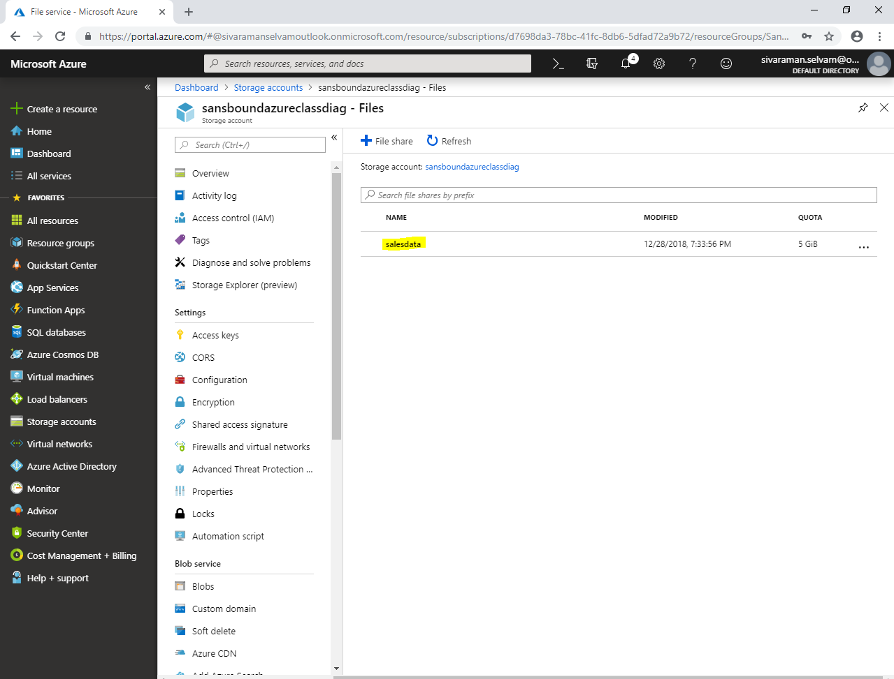

In **“salesdata”** file share click **“Properties”**.

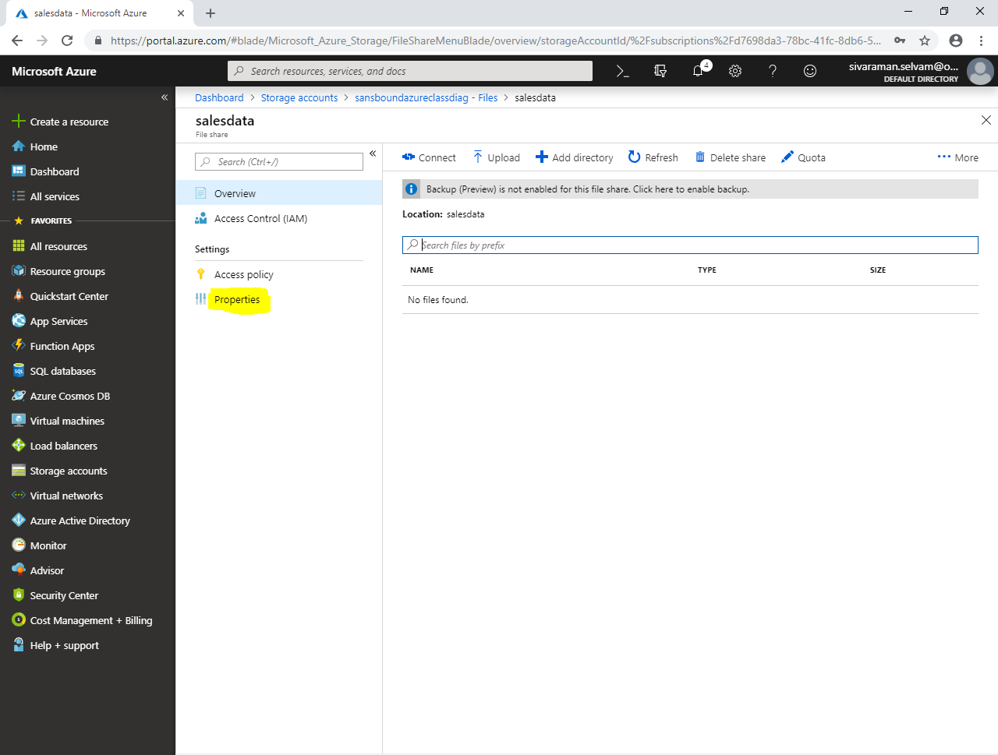

In **“salesdata”** – Properties

Click **“Icon”** to copy the path for **“Files”** storage.

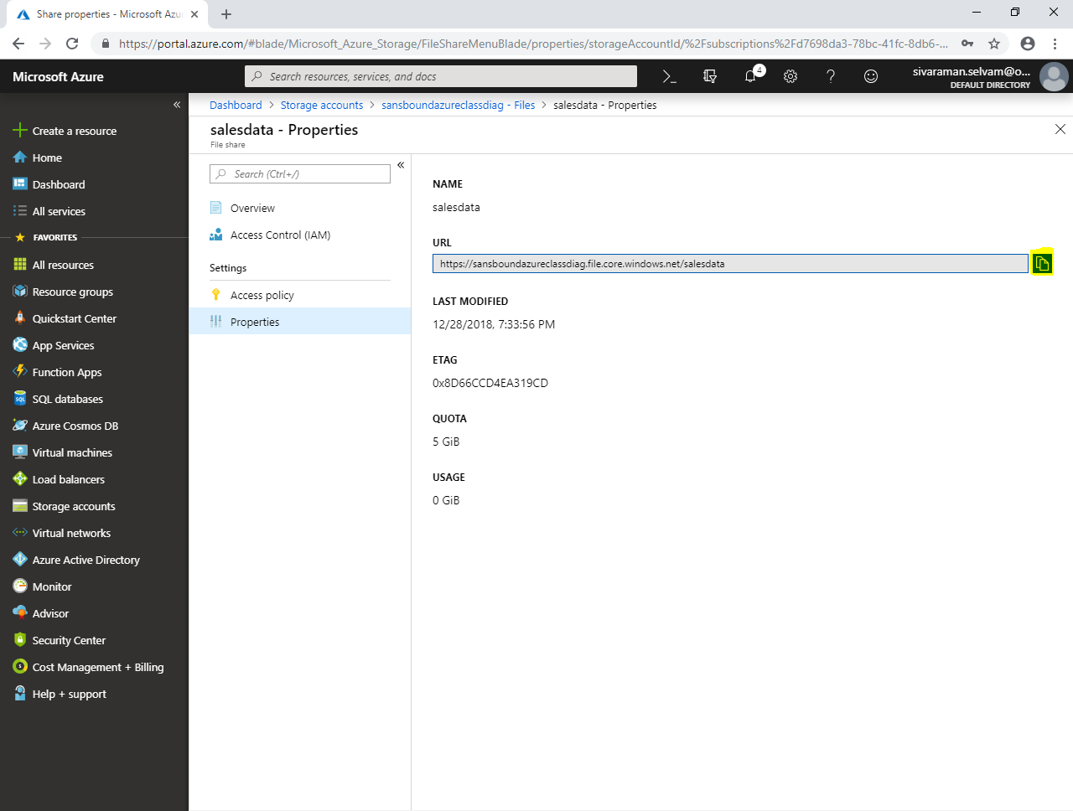

Click **“Storage accounts”** in left side panel.

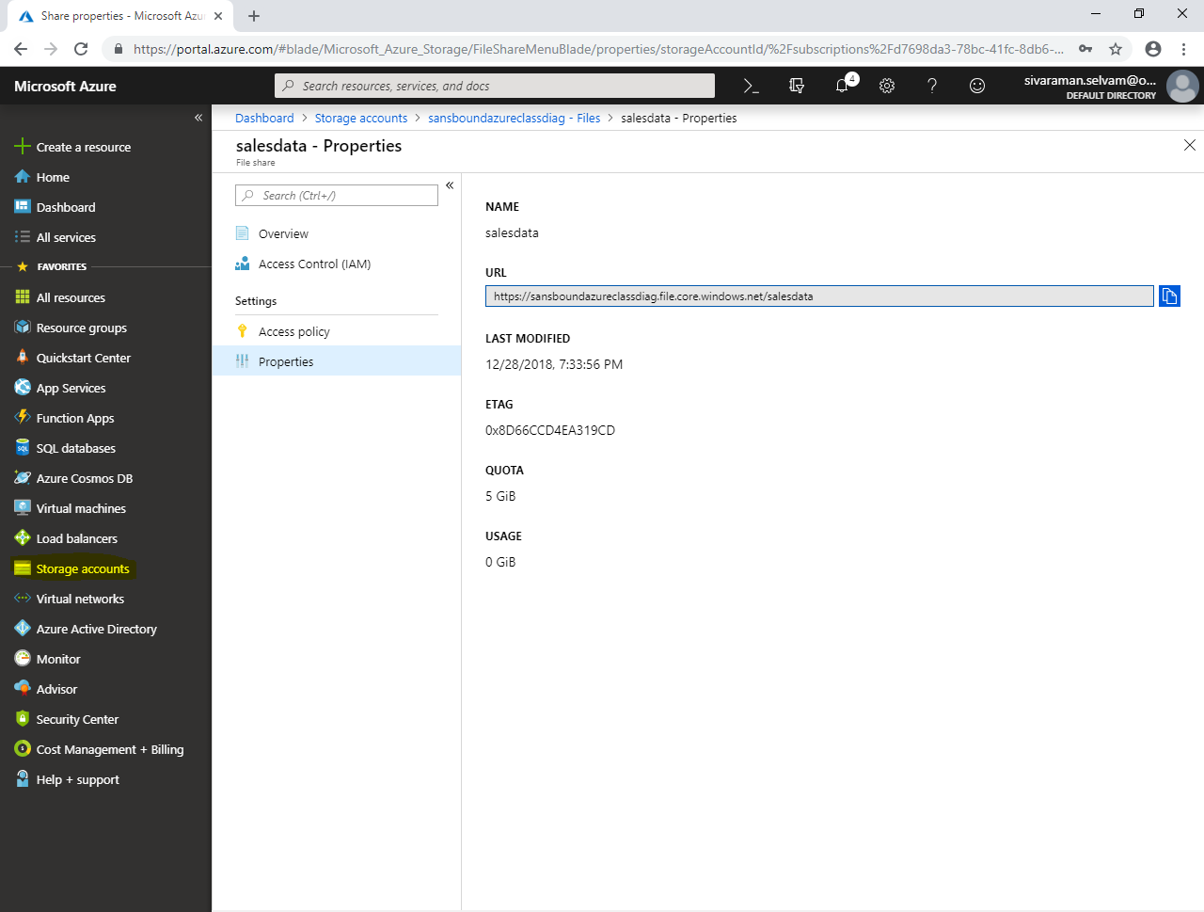

In **“Storage accounts”** click **“storage name”**.

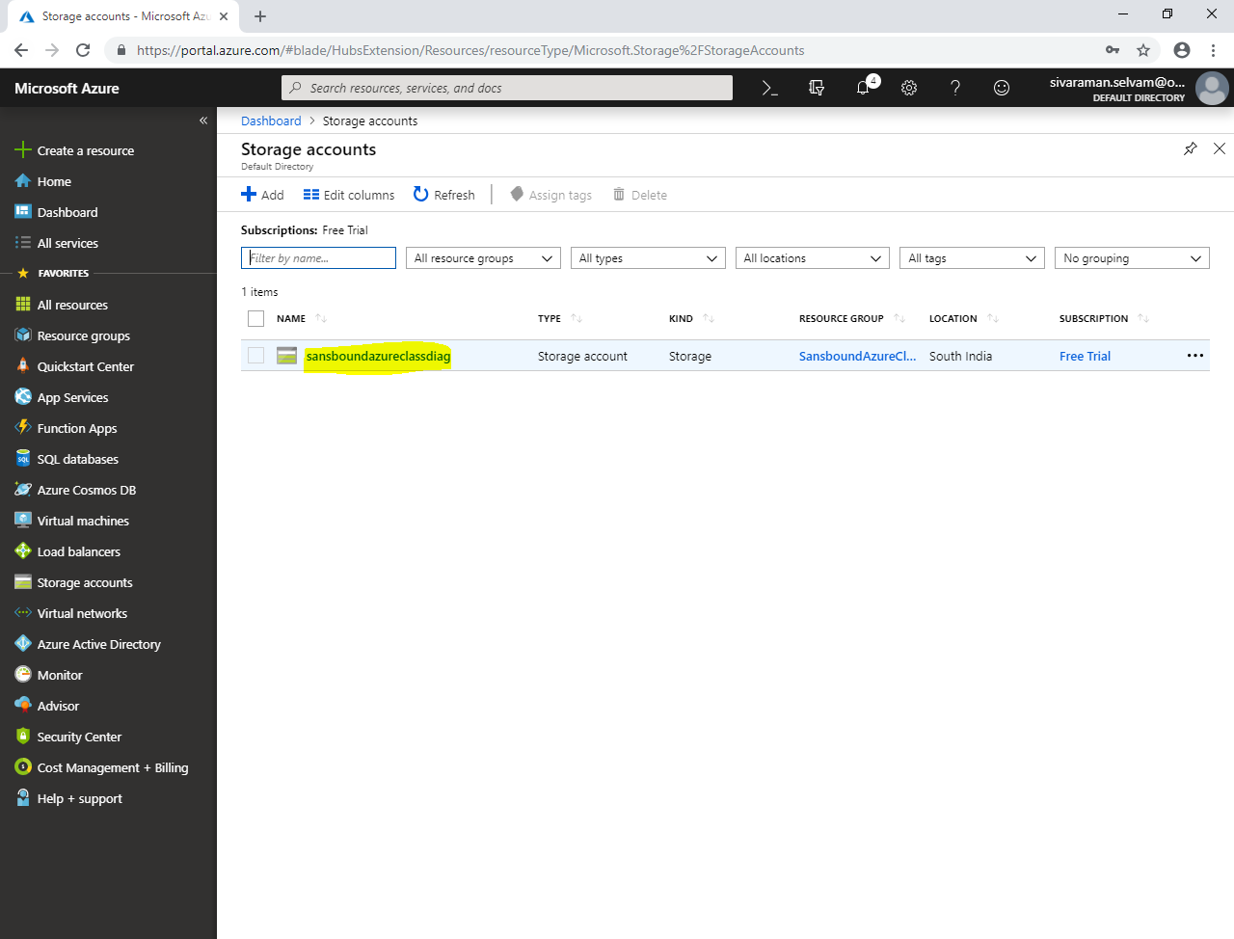

Click **“Files”.**

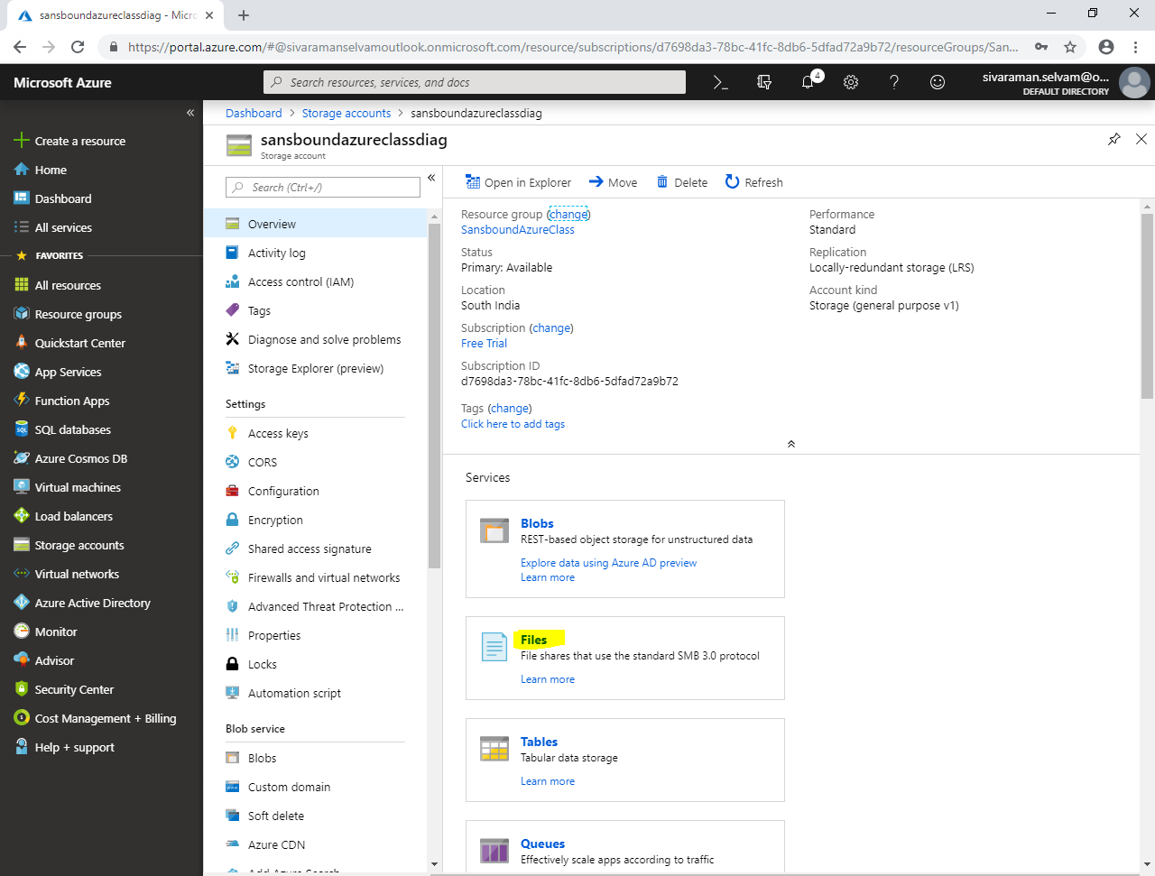

In **“Files”**

Click **“Access keys”** to login credentials of the **“Files”** storage.

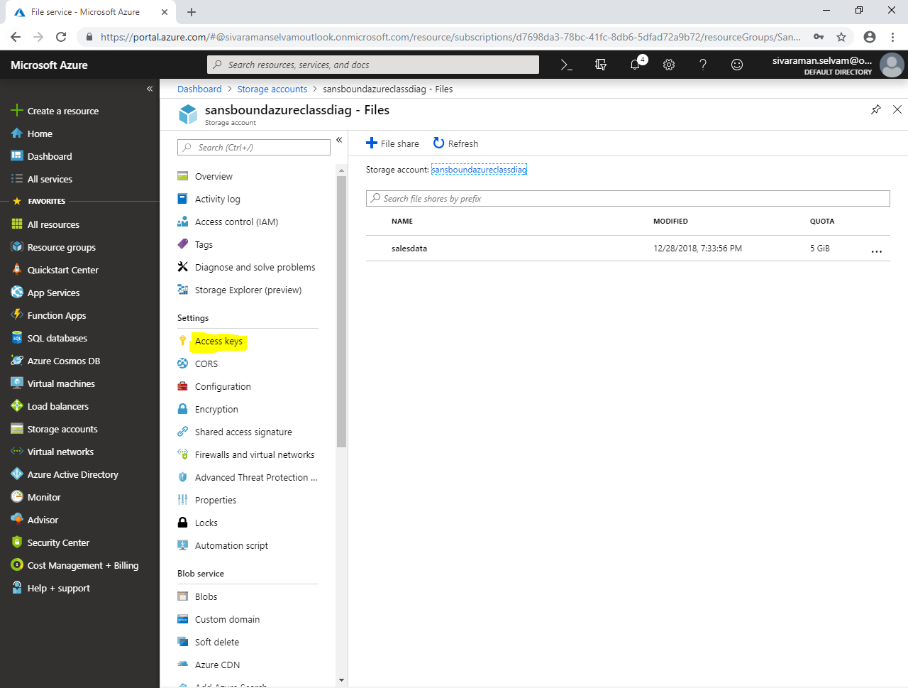

In **“Access keys”.**

In **“Storage account name”** click **“Icon”** to copy.

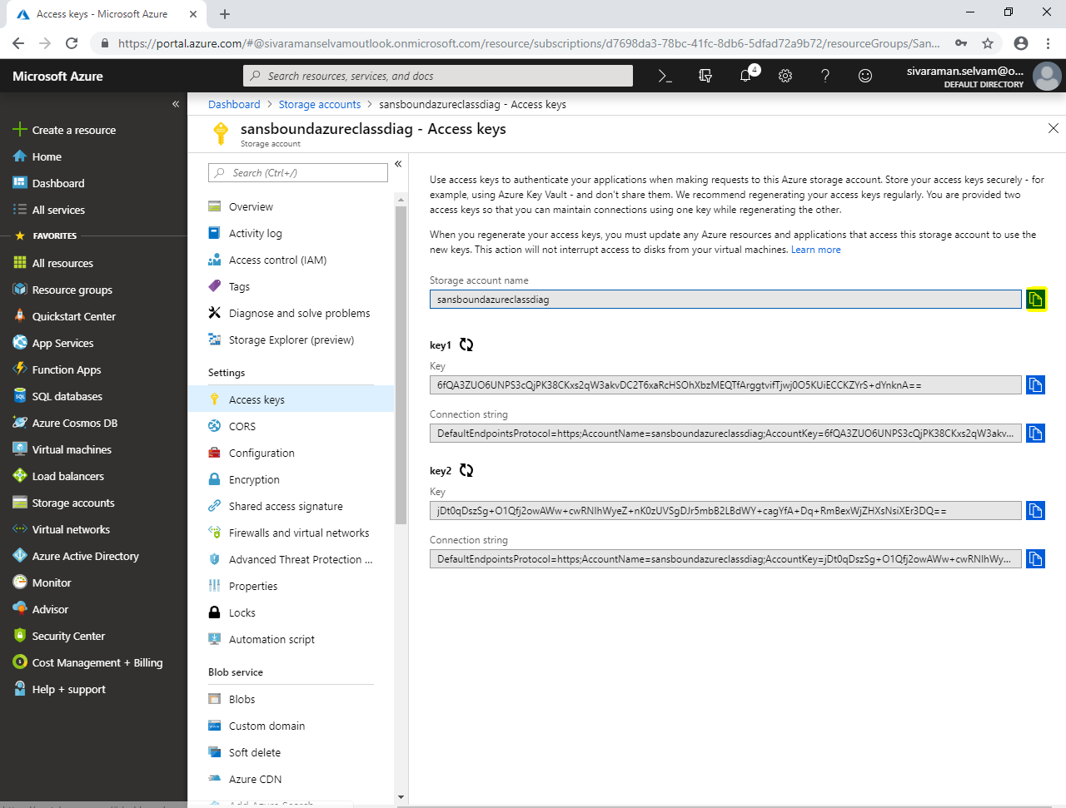

Copy the “Key” by click **“Icon”**.

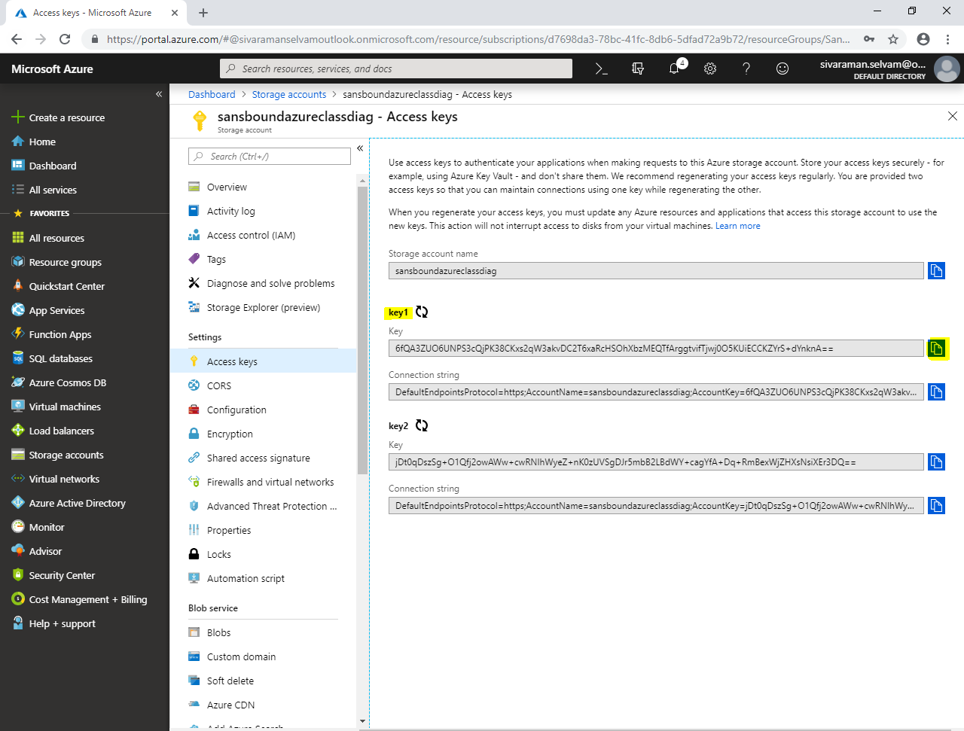

Copy the **“connection string”** by click **“Icon”**.

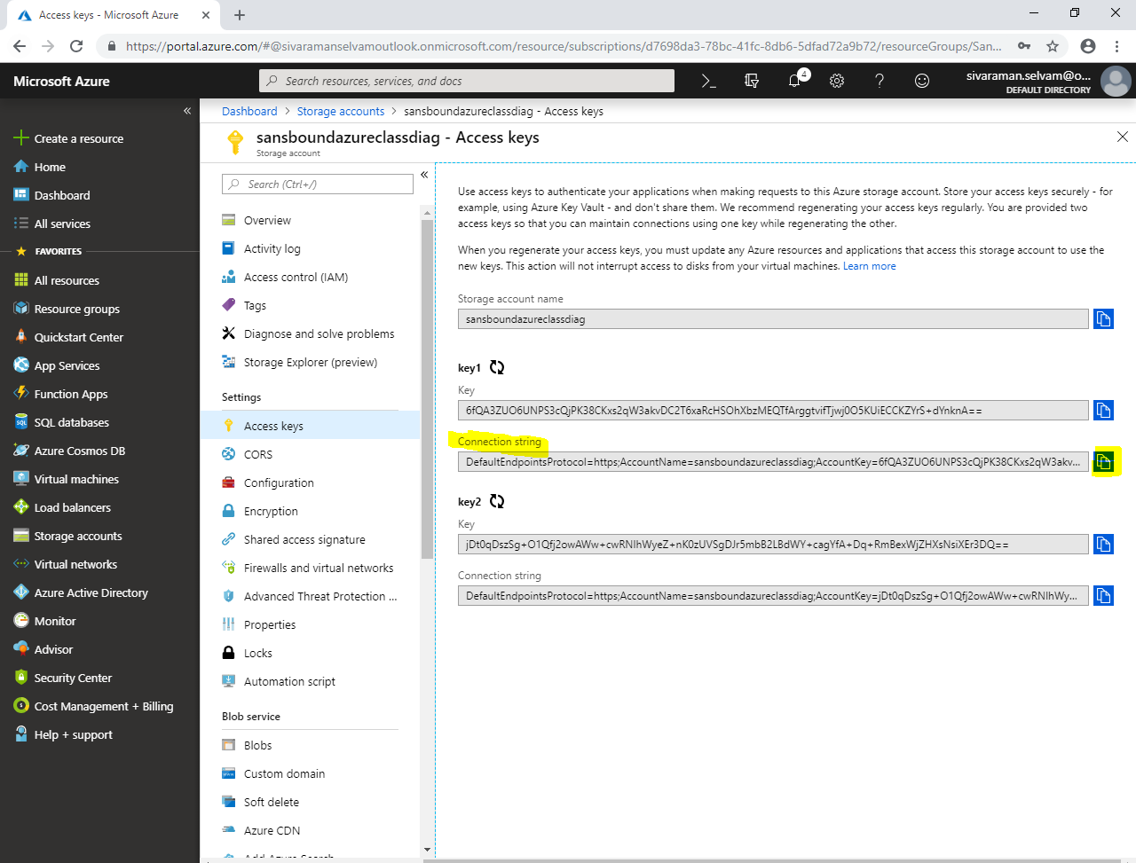

Click **“Storage accounts”**.

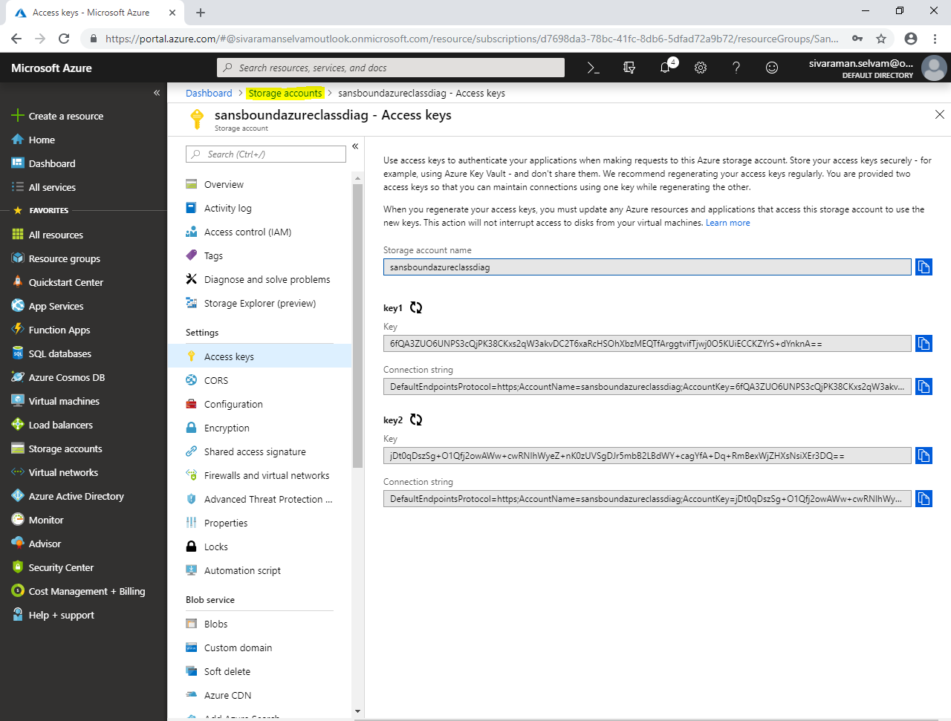

In **“Storage accounts”**.

Click **“sansboundazureclassdiag”**.

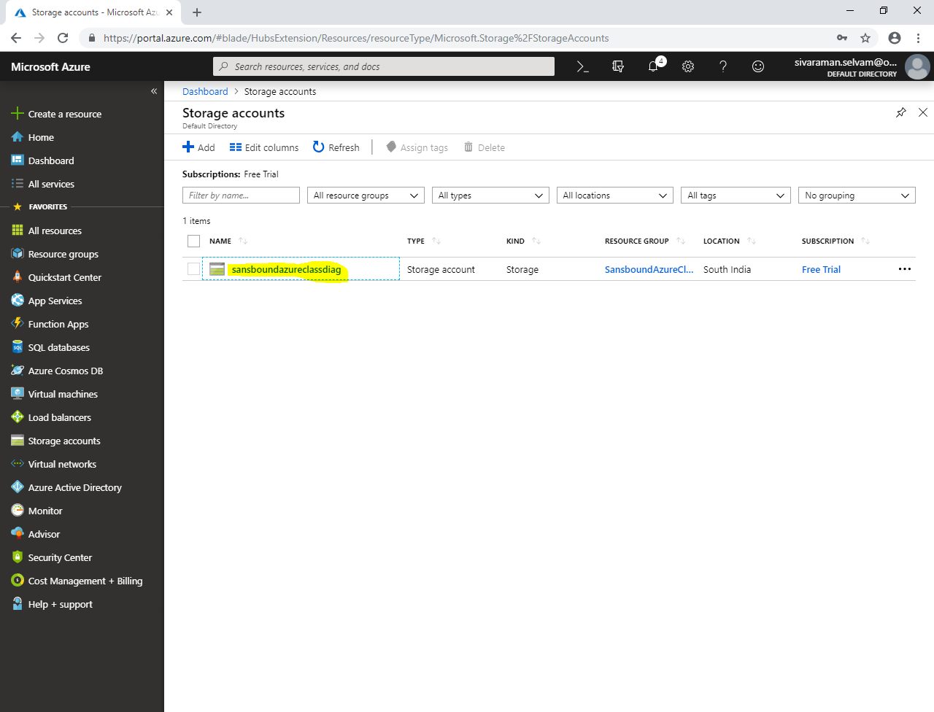

Click **“Files”**.

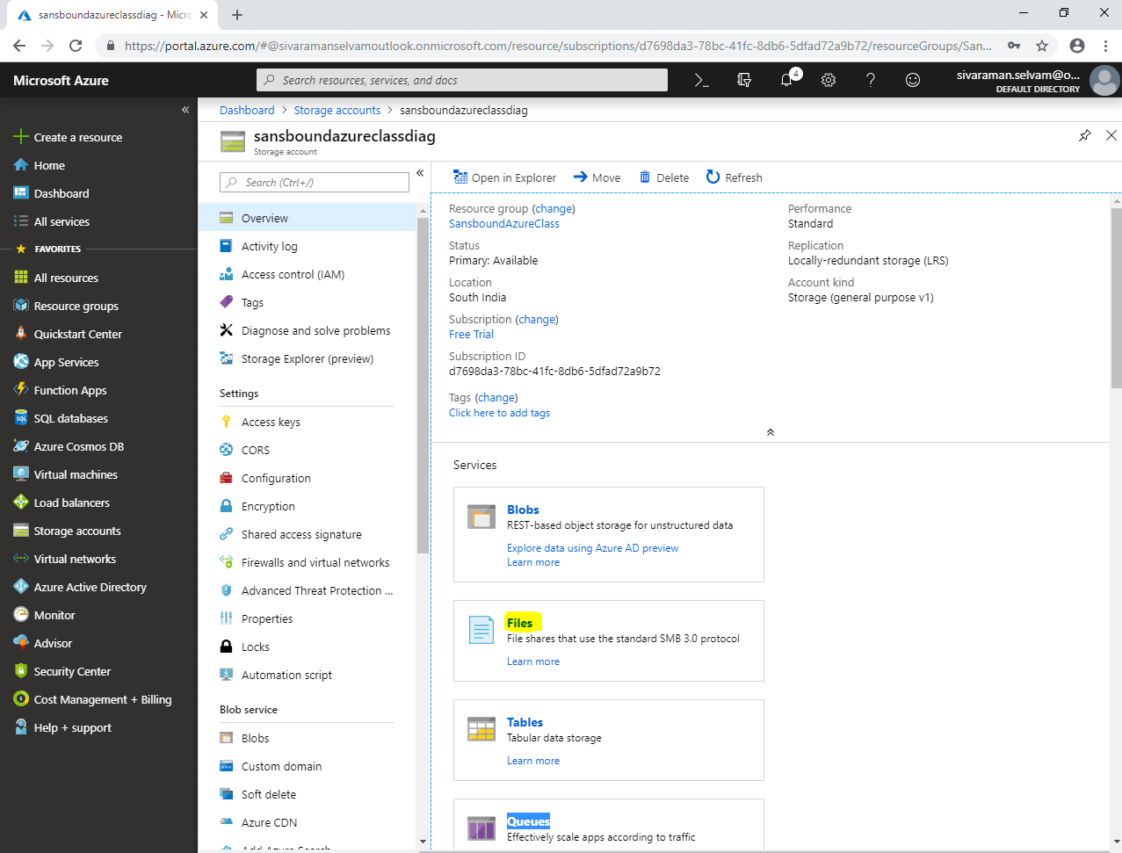

Click **“salesdata”**.

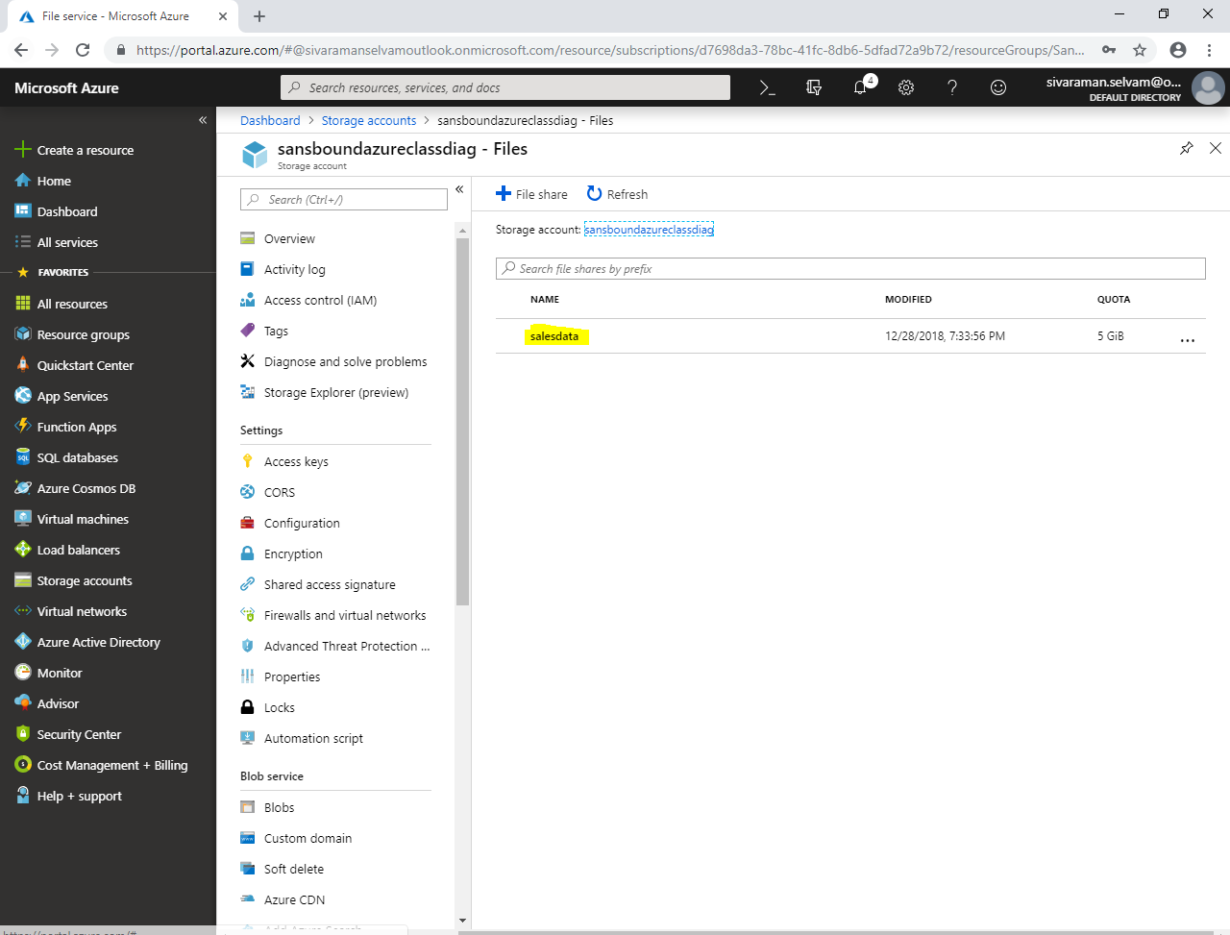

Click **“Upload”** to upload data from On premises to Azure Files storage.

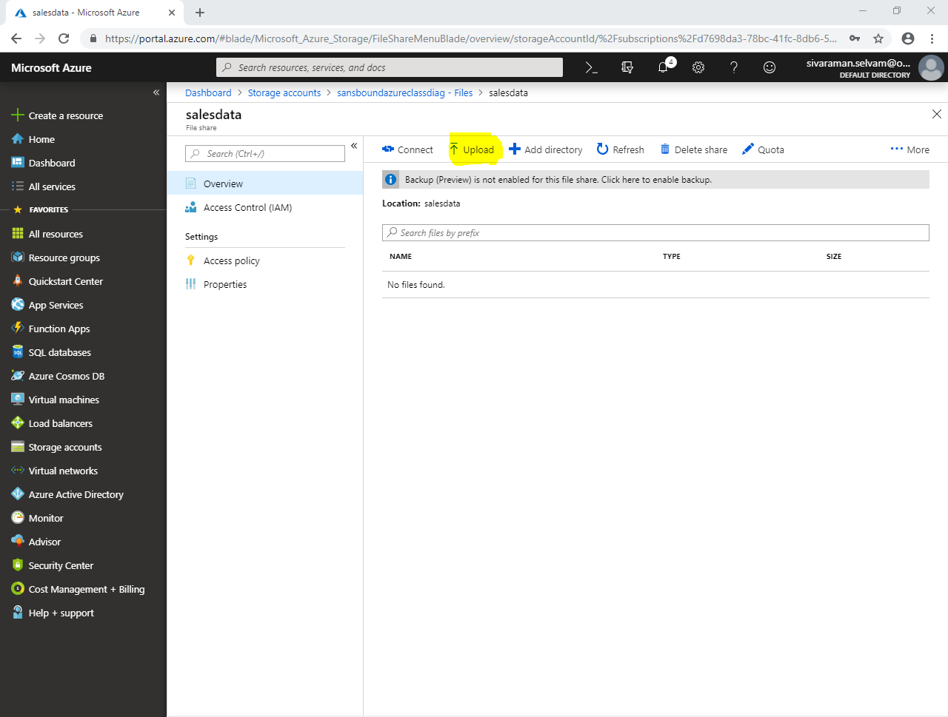

In **“Upload files”**

Click **“icon”** to select files to upload.

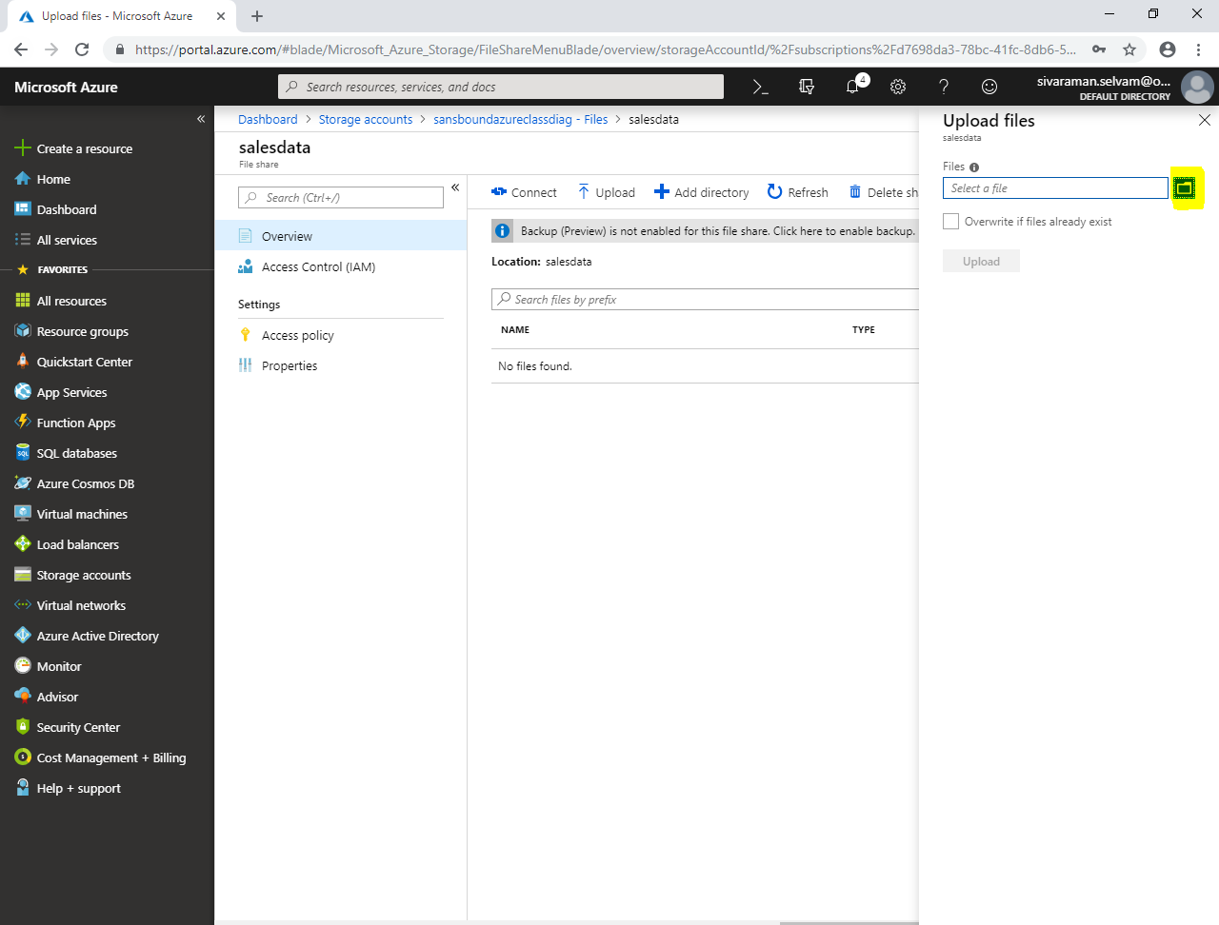

Locate the data in your local drive where you have stored.

Click **“Open”.**

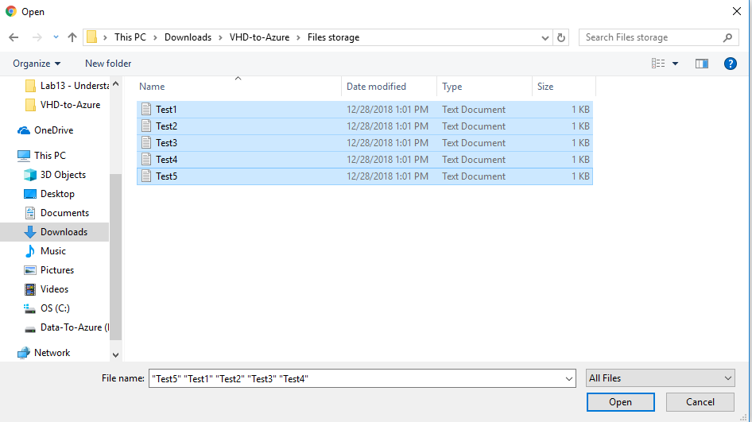

Click **“Upload”**.

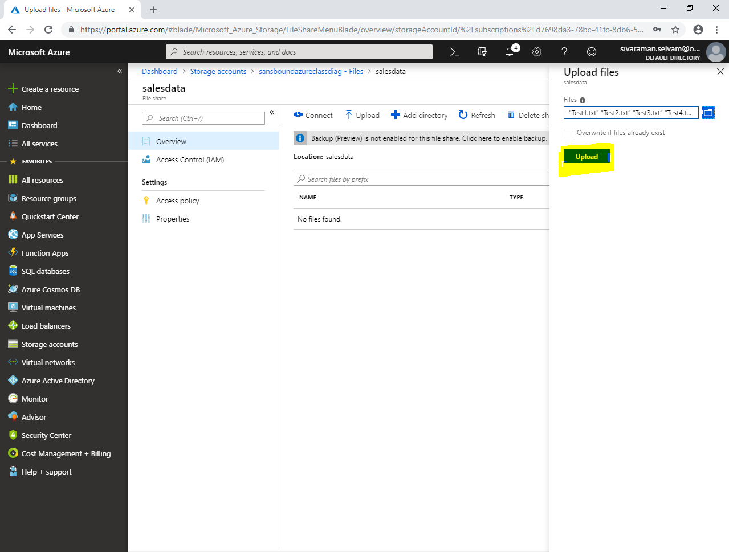

You have uploaded files from on premises successfully.

In **“Files”** storage, everyone can able to view the files of other user.

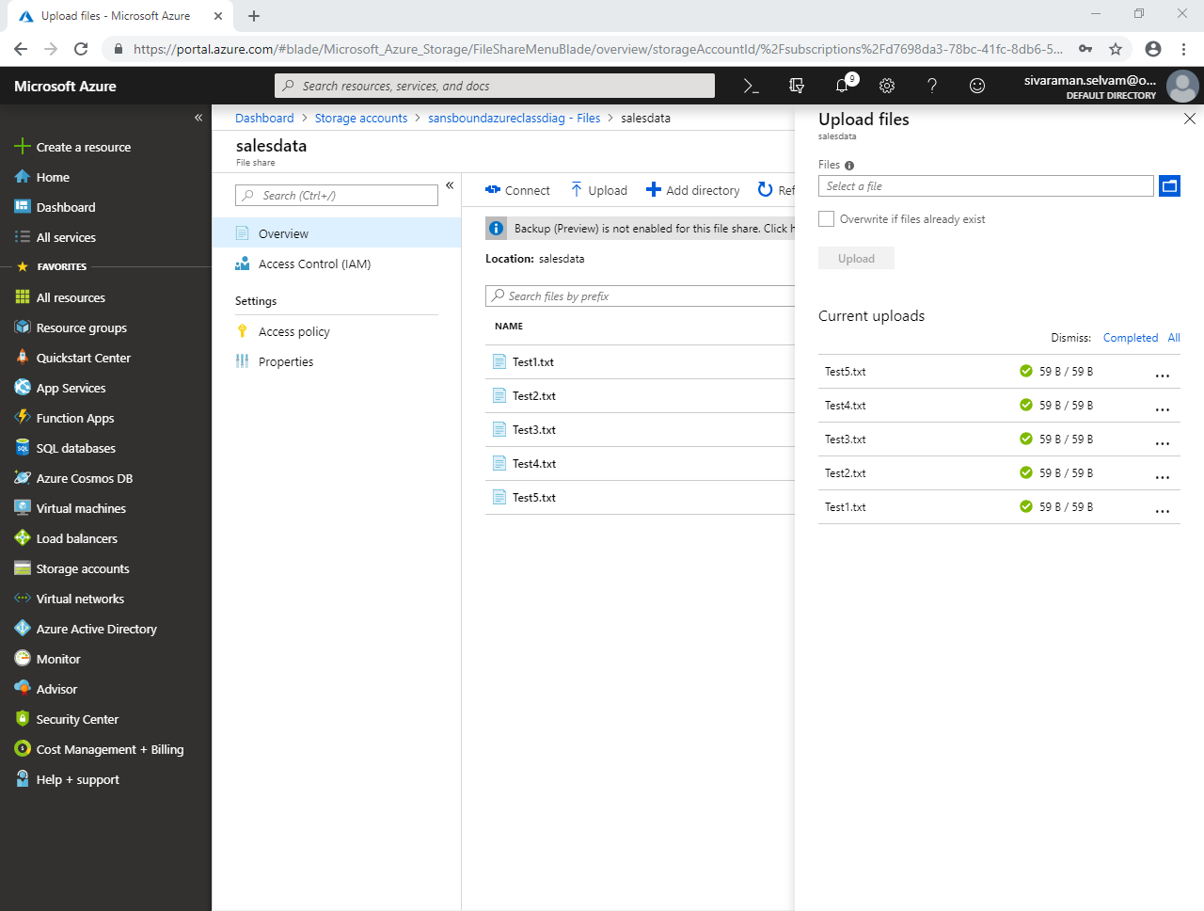

Click **“Virtual machines”** in left side panel.

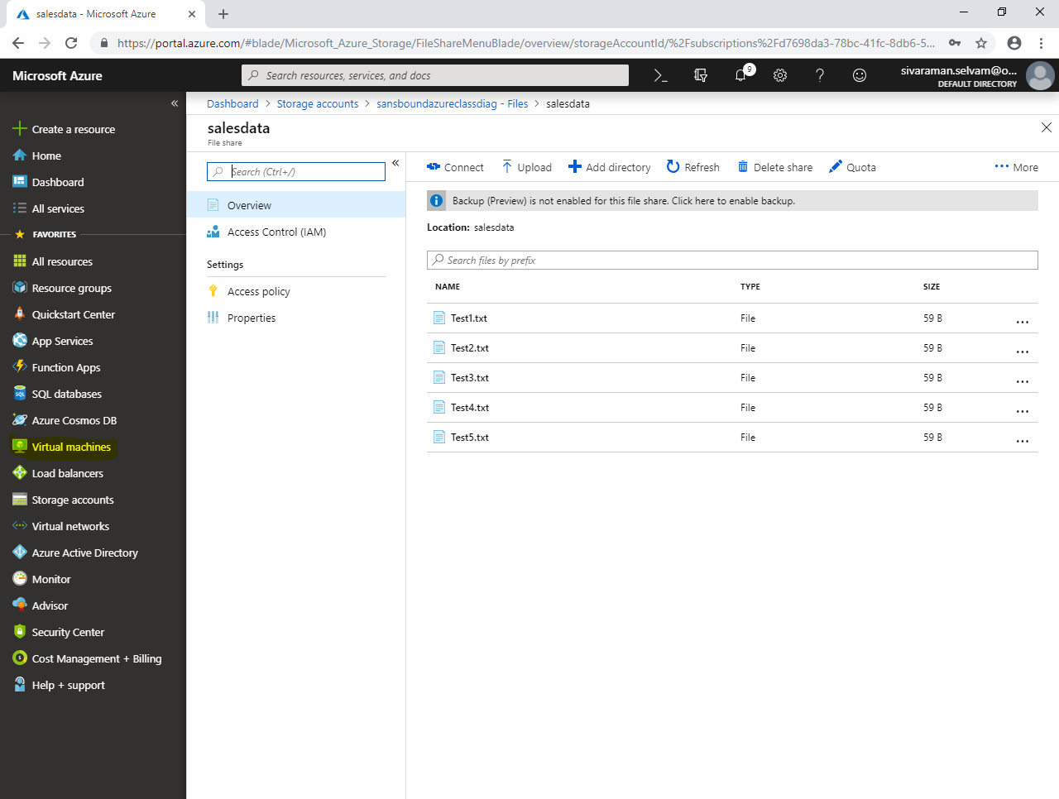

In **“Virtual machine”**.

Click **“WindowsVM-Azure”**.

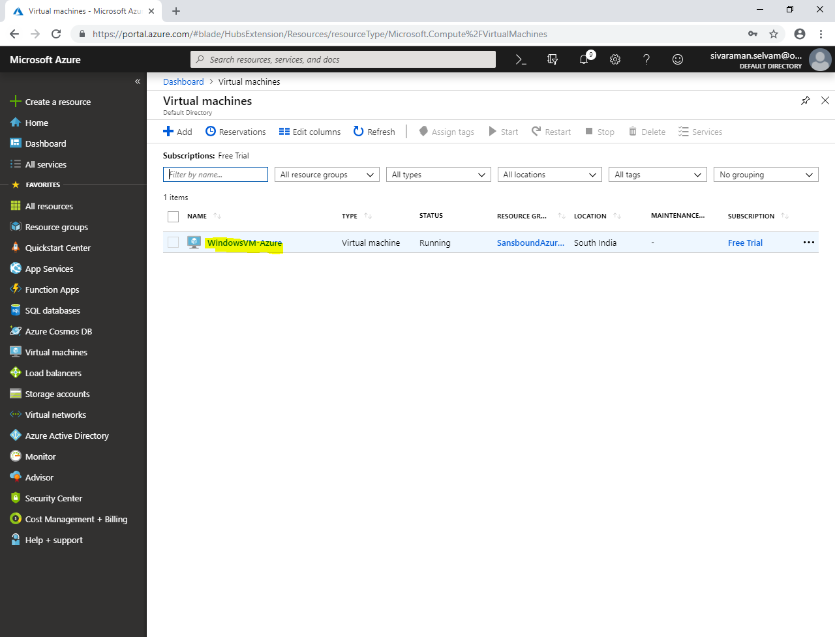

Kindly note the Public IP address provided for “Windows Server 2008 R2”.

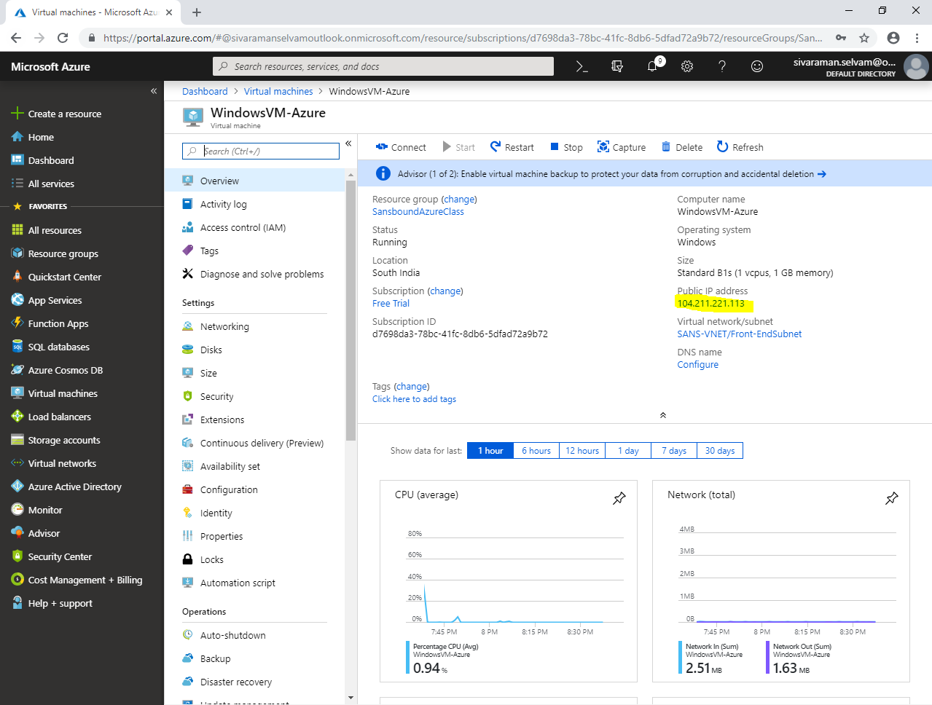

In your local machine, type **“mstsc”** in **“Run”** box and click **“Ok”**,

Type “Public IP” of Windows server 2008 R2.

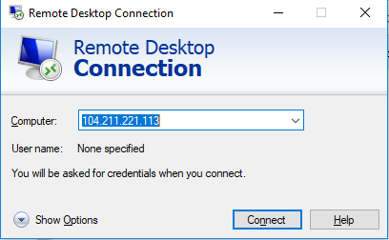

Click **“Connect”.**

Type Username and password for the Windows 2008 Server

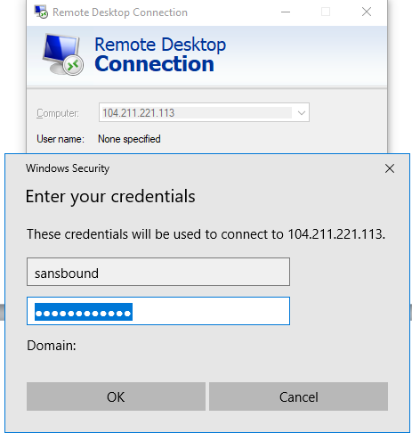

Click **“Ok”**.

Click **“Yes”.**

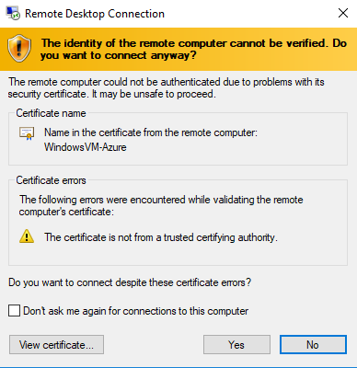

From “Access key” you have copied below details to access the “Files” storage from Virtual machine in Azure.

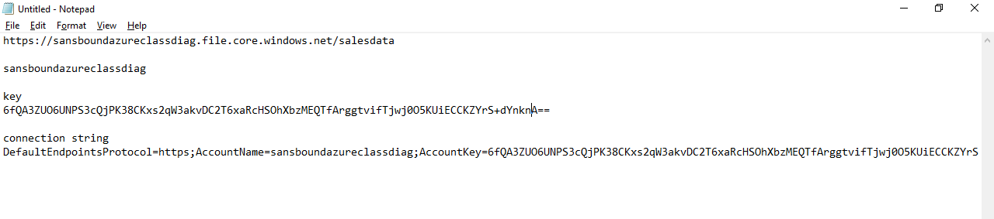

You can able to access the Files storage from virtual machine by using share path UNC: **“\\”**

**So, you have need to modify the arguments as ‘//” with “\\” and “/” with “\”.**

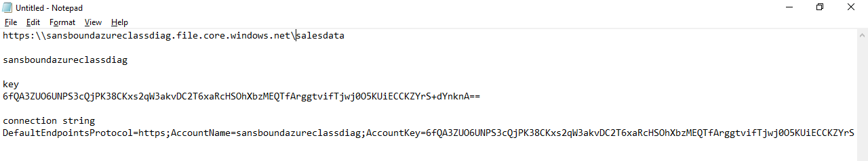

In **“Windows 2008 Server R2”** Virtual machine,

In “Computer”

Click **“Map network drive”**.

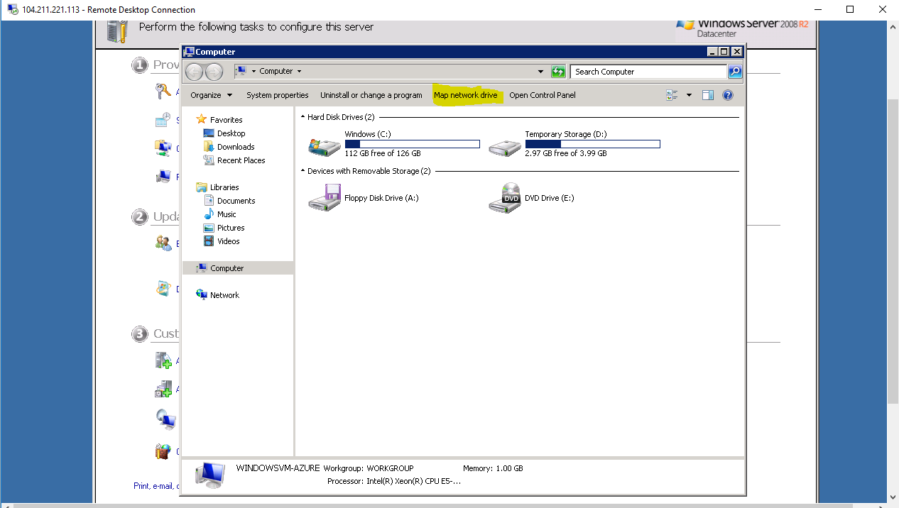

Remove **“https:”** from the UNC path copy the “Files” storage as UNC path.

**\\sansboundazureclassdiag.file.core.windows.net\salesdata**

**Map Network drive**, in **“Folder”** paste the UNC path of “Files” Storage.

Check **“Connect using different credentials”**.

Click **“Finish”**.

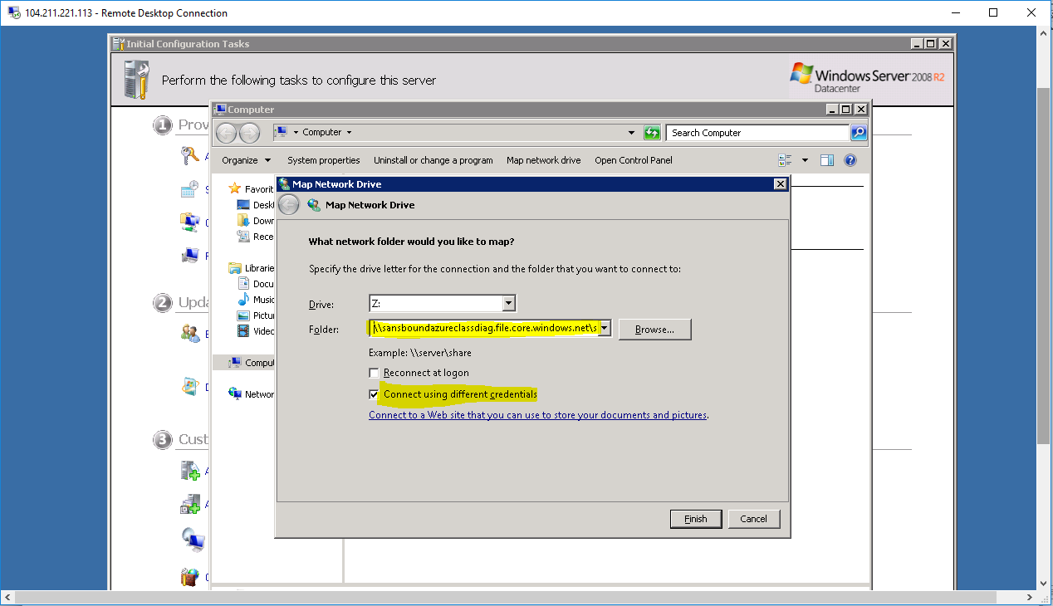

It requires username and password.

In username type Azure\storage name

Our storage name is “sansboundazureclassdiag”.

Our storage name is sansboundazureclassdiag, so i have type username as **“Azure\sansboundazureclassdiag”**

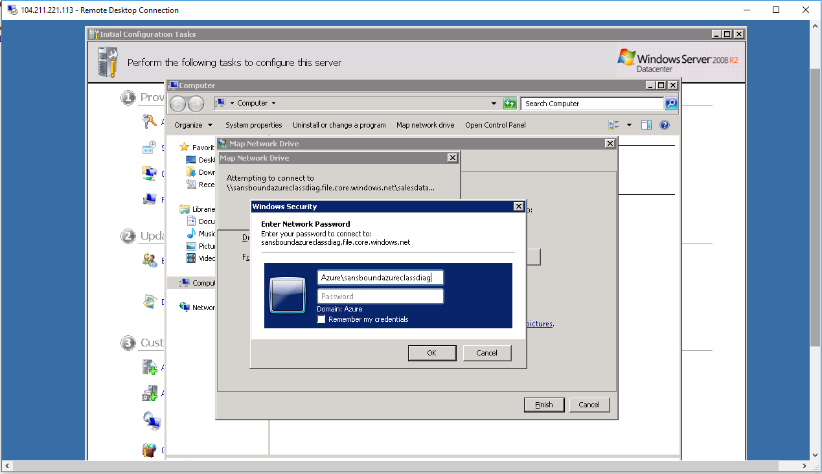

Copy the key which you have copied from “Files“ storage and paste it in “password” box.

**6fQA3ZUO6UNPS3cQjPK38CKxs2qW3akvDC2T6xaRcHSOhXbzMEQTfArggtvifTjwj0O5KUiECCKZYrS+dYnknA==**

Click **“Ok”** to map the network path as drive.

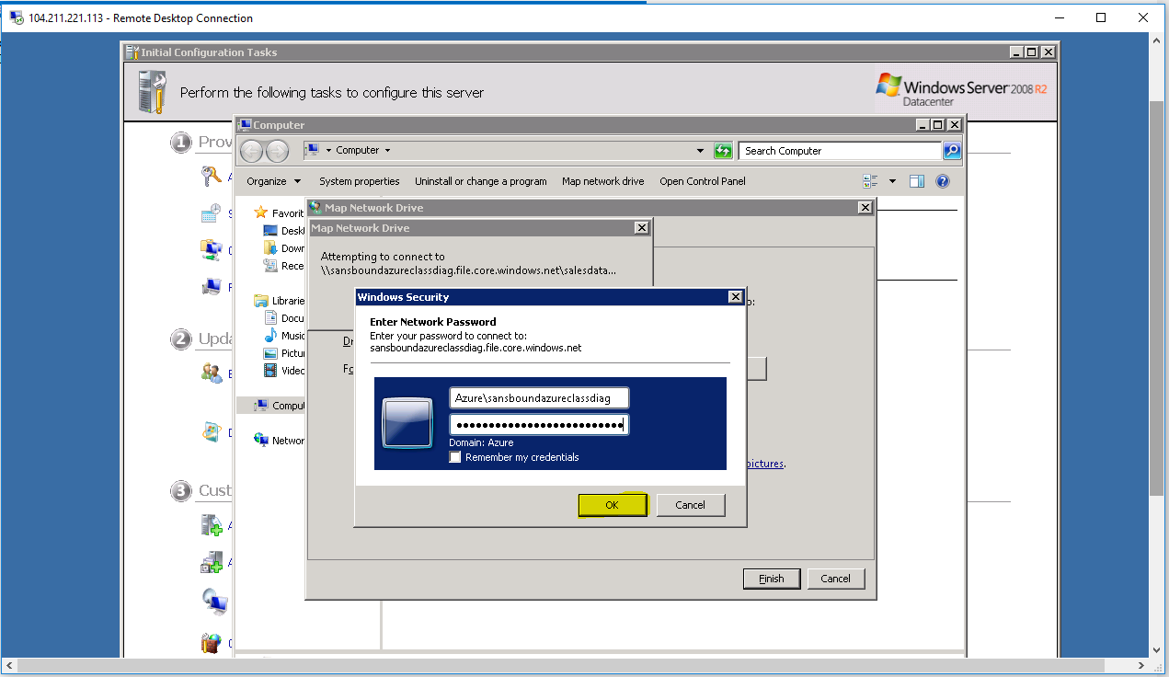

You have successfully mapped the **“Files”** storage in Azure virtual machine.

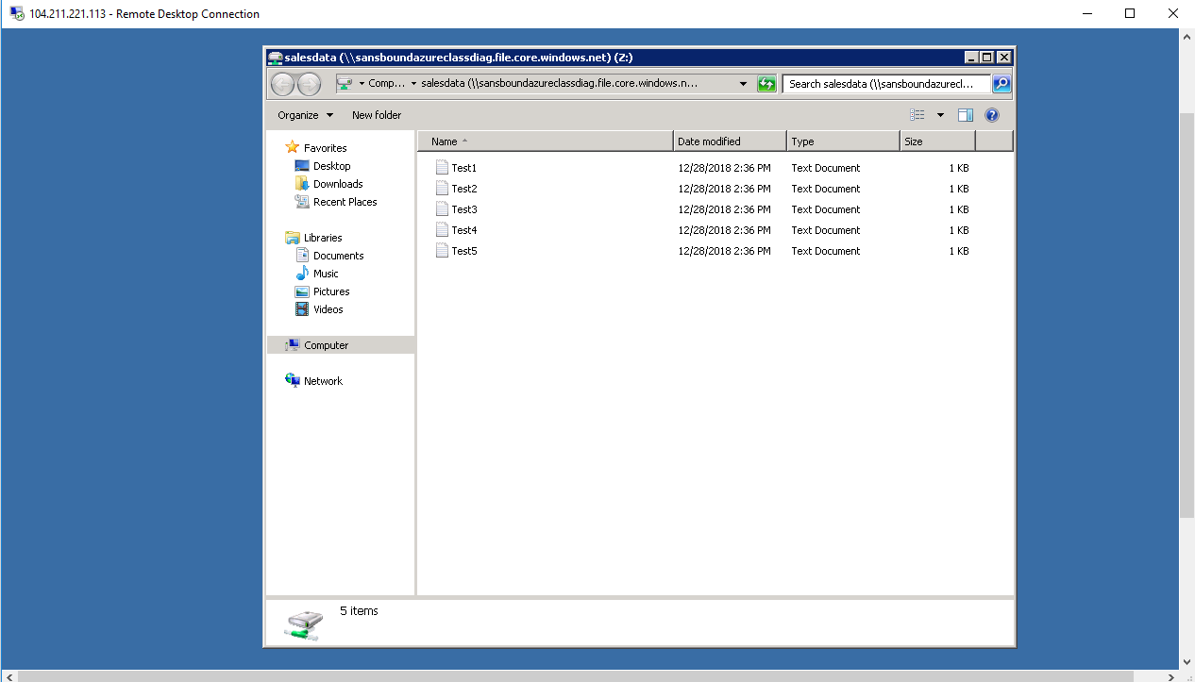

In **“Files”** storage I have created one folder named **“data”** and created one file named **“Data1.txt”**.

Other users who have accessed this share also can able to access the folder(s) / file(s) of others.

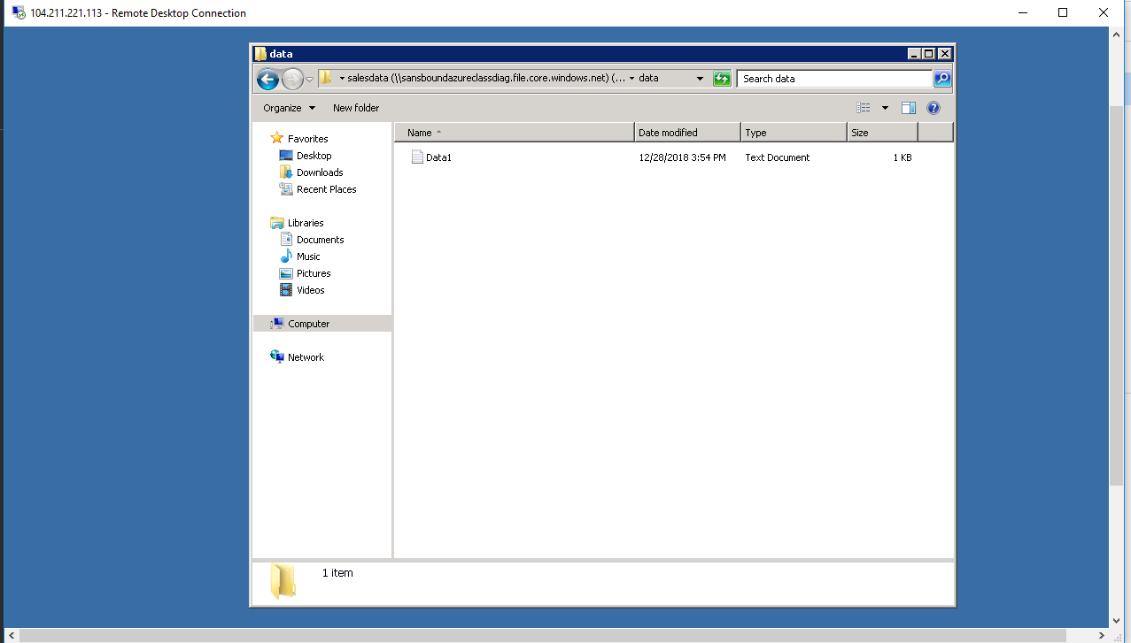

In Dashboard click **“Storage accounts”**.

In **“Storage accounts”** click storage account name.

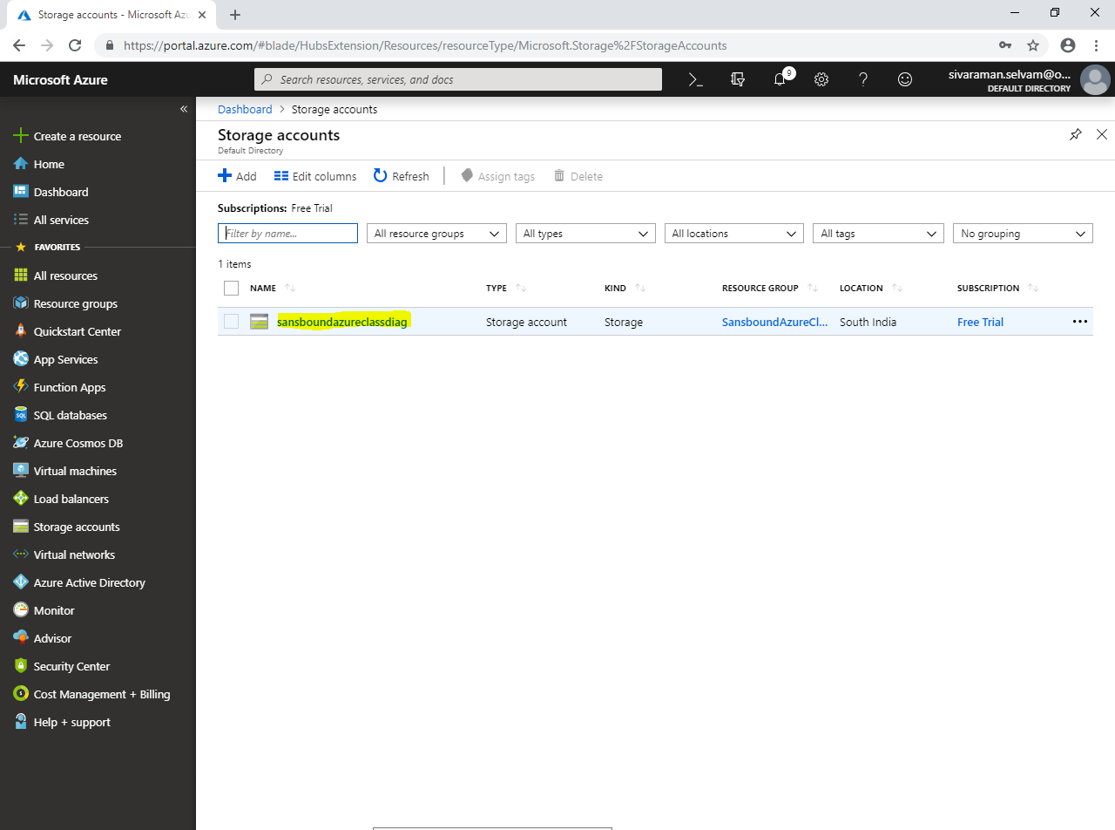

Click **“Files”.**

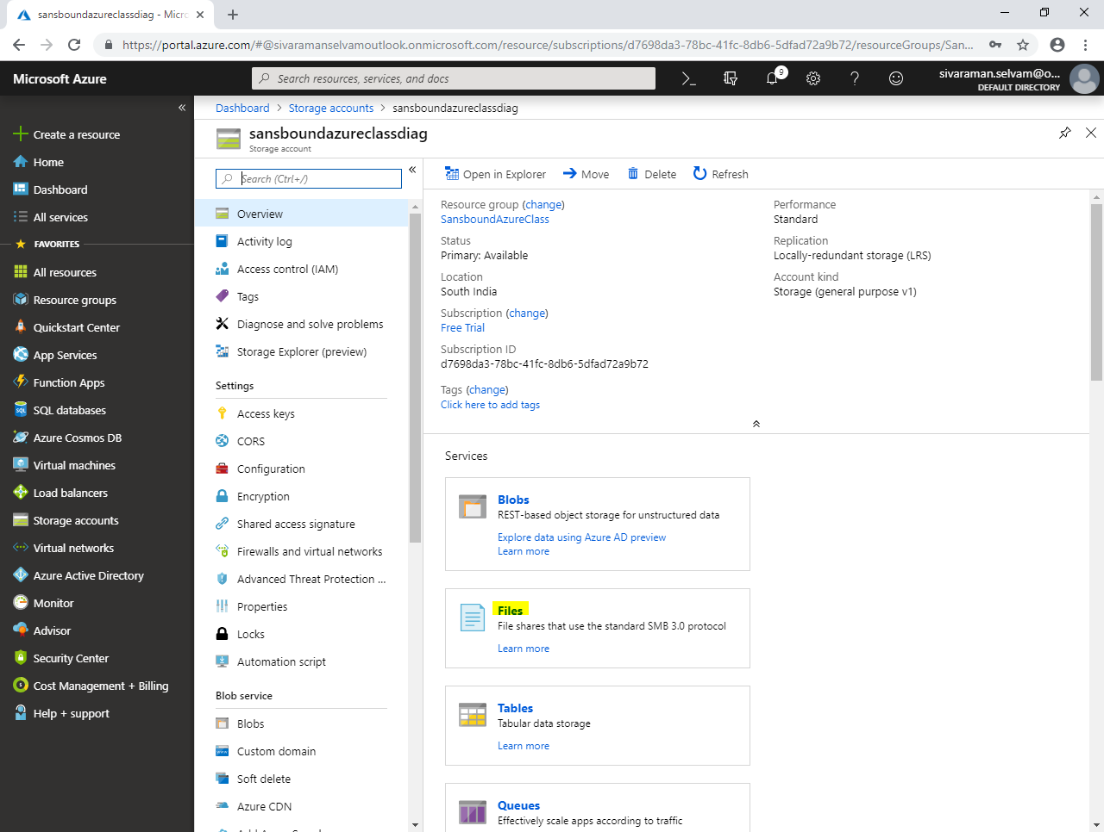

Click **“salesdata”.**

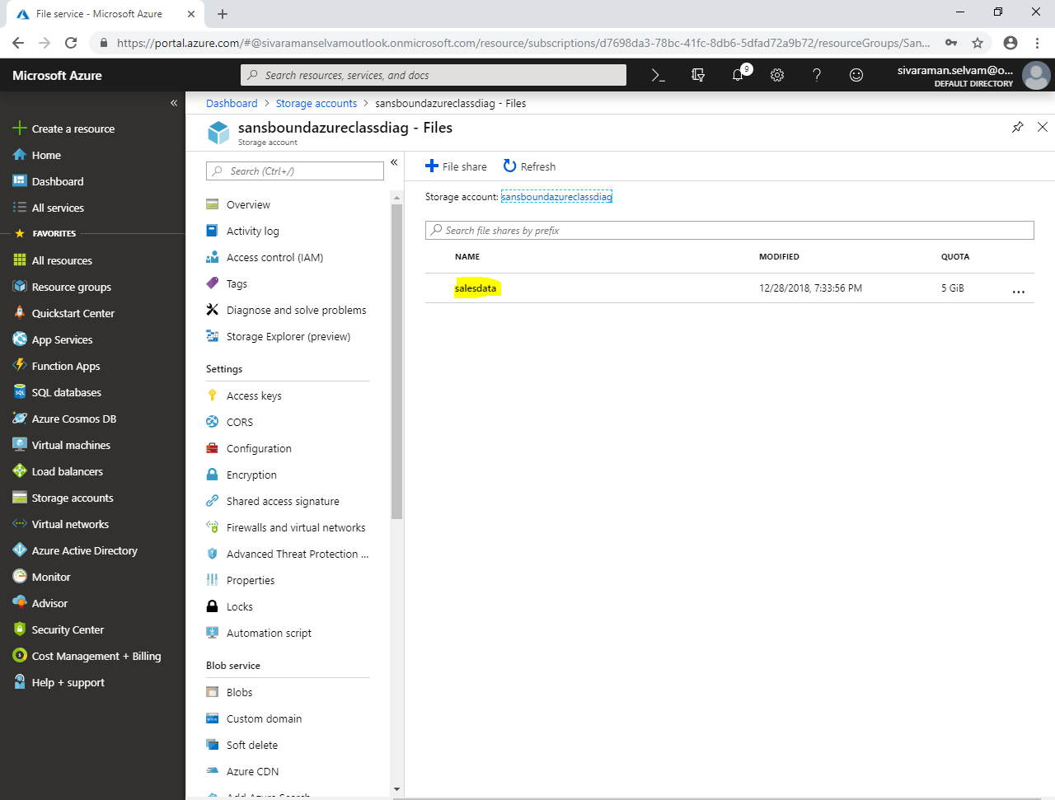

You are able to see the folder named **“data”** which has been recently created.

Click **“data”** folder.

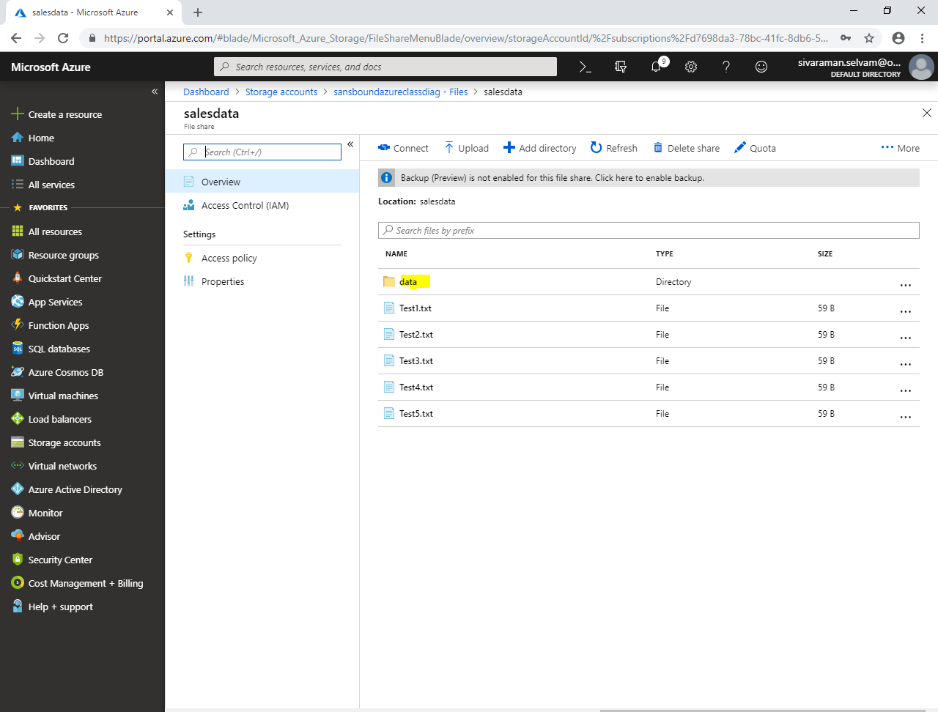

Select **“Data1.txt”** file to **Download / Delete.**

Note: Administrator have access to view / delete the files / folders in the “Files” storage.

